

**Advanced Databases (ADB)**

October 2023

**SCHOOL OF INFOCOMM TECHNOLOGY**

Diploma in Information Technology / Data Science

**ADB Assignment 2**

**(40% of ADB Module)**

**22 January – 2 February 2024 (2 Weeks)**

**Deadline: 2 February 2024, 23:59**

|  |  |  |
| --- | --- | --- |
| **Tutorial Group** | : | P02 |
| **Tutor** | : | Choon Peng TAN |
| **Team No.** | : | Team 01 |
| **Date of submission** | : |  |
| **Late** | : | ~~YES /~~ NO |

**Please fill in your Student Number and Name as appear on your student card:**

|  |  |  |  |
| --- | --- | --- | --- |
| **Details of individual contribution** | **Student No.** | **Student Name** | **Overall Grade** |
|  | S10241996 | Lim Yi Hui |  |
|  | S10243666 | Jovin Wong See Xuan |  |
|  | S10242248 | Amelia Quek |  |
|  | S10243067 | Oh Ern Qi |  |

**Table of Contents**

1. Final business domain write-up - 3 -

2. Final ER model and the list of mapped relations - 7 -

2.1. Final ER model - 7 -

2.2. Mapped Relations - 8 -

3. How your cloud database design meets the requirements of the entire system - 10 -

5. Tables - 18 -

Amelia - 18 -

Genre Table - 18 -

Podcast Table - 23 -

PodcastEpisode Table - 36 -

Podcast Log Table - 44 -

Download Table - 54 -

Review Table - 63 -

Business Queries (revised) - 69 -

Yi Hui - 70 -

Jovin - 71 -

User table - 71 -

Subscriber table - 80 -

SubscriptionPlan table - 87 -

TransLog table - 89 -

Business Queries (revised) - 92 -

Ern Qi - 94 -

Followers Table - 94 -

Recommendations Table - 100 -

Advertising Table - 110 -

Artist/Band Table - 113 -

Song Log Table - 119 -

Business Queries (revised) - 122 -

# Final business domain write-up

**User Registration and Authentication**

Musify allows people to sign up for an account. By providing basic information, such as their email address, username, password, and Date of Birth, users would be able to register for an account. People aged 16 and above can sign up for an account. Signing up for an account would suggest that the user is currently on the Musify Free plan. Musify users are then able to upgrade to the various premium plans available. However, to upgrade to a premium account, users would be required to include their preferred payment method - Credit or Debit Card, PayPal or ShopeePay. The account then includes sensitive information which needs the app to be secured. The app should prioritise security with a robust authentication system to safeguard sensitive information to protect the Musify users.

**Subscription Management**

Users can change their subscription plans – Individual, Family, Duo, and Student. Musify Free would include basic features with advertisements. At the same time, Musify Premium Plans would entitle users to an ad-free experience, higher audio quality and offline listening where users can download their favourite songs. Different premium plans would have different prices. Users will be charged monthly or yearly, and if they choose to change their subscription plan midway through a paid period, the switch will take effect immediately. The updated plan will continue until the remaining credits from the prior subscription plan expire. To upgrade the subscription plan, users must pay the prorated amount until the next billing day. The new billing day will be the day when they changed their subscription plan. The premium plan subscribers can pay their subscription fee through Credit or Debit Card, PayPal or ShopeePay.

**Advertisements**

The Audio Advertisement feature on Musify seamlessly integrates promotional content into the user experience, strategically placing targeted audio ads between songs or at specified intervals. This enhances the freemium model, allowing Musify to generate revenue while providing free content. Advertisers create engaging audio content aligned with their brand, and Musify employs sophisticated targeting criteria, considering demographics, location, user activity, and music preferences. Premium subscribers enjoy an ad-free experience, incentivizing subscription. The feature benefits Musify by contributing to revenue, increasing user engagement, monetizing free content, and offering advertisers a customizable platform for effective promotions.

**Browse Music**

Musify features a powerful search engine designed to enhance user experience by providing swift and accurate results. Whether users are searching for specific songs, albums, artists, or podcasts, the comprehensive search results ensure that they find exactly what they are looking for. The seamless exploration experience is a hallmark of Musify, allowing users to effortlessly discover and enjoy their favourite audio content. Furthermore, Musify goes beyond basic search functionalities, offering users the opportunity to delve into the world of music and other audio genres. The platform's genre-based exploration feature enables users to navigate through a carefully curated selection of tracks, albums, and playlists tailored to each user’s unique musical preferences. This personalised approach ensures that users not only find what they are searching for but also stumble upon new and exciting content that aligns with their taste.

**Discover Music**

Musify takes music discovery to the next level with its innovative features, including the Trending Charts and New Release functionalities.

The Trending Charts feature offers users a real-time glimpse into the music industry by showcasing the most popular and widely listened to tracks in the platform. This ensures that users are updated with the latest hits, emerging artists, and current music trends. Staying connected to the pulse of the musical community, users can explore and enjoy the hottest and most talked-about songs.

Additionally, Musify introduces the 'New Release' feature, serving as a dynamic gateway to the freshest content in the music industry. This feature not only keeps users well-informed but also encourages exploration by presenting opportunities to discover new genres and emerging talents. Musify thus becomes a comprehensive platform, catering to both the desire for the latest hits and the excitement of exploring new and undiscovered gems

**Playlist Creation**

Playlist creation on Musify allows users to create personalised playlists by selecting and arranging their favourite songs or podcast episodes, empowering users with a personalised and expressive music curation experience. Beyond individual efforts, Musify introduces collaborative playlist creation, enabling real-time collaboration among users. This social dimension allows friends and followers to collectively contribute to and refine playlists, fostering shared musical experiences. Incorporating intelligent playlist curation algorithms, Musify further enhances user engagement by providing automated recommendations based on listening habits and preferences. Smart playlists and the ability to seamlessly integrate with third-party applications add depth to the playlist creation process, ensuring users have dynamic and diverse options that evolve with their changing moods and interests.

**Playlist Management**

In the realm of playlist management, Musify offers users a suite of robust tools and services. Playlist editing functionalities allow for dynamic adjustments, empowering users to modify existing playlists by adding, removing, or rearranging tracks as their preferences evolve. Users can share their playlists with friends and followers easily. as well as follow other users, see their public playlists, and discover new music through shared playlists or searching for specific playlists or discover new ones through curated playlists, trending lists, and genre-specific recommendations. This function facilitates exploration and helps users find playlists aligned with their interests. The integration of offline playlist access caters to users' on-the-go lifestyles, allowing them to enjoy curated music even without an internet connection. Musify's commitment to continuous play and autoplay ensures a seamless transition between playlists, offering an uninterrupted listening experience.

**Recommendations:**

This feature plays a crucial role in enhancing user experience, engagement, and the overall success of Musify in the rapidly evolving music streaming industry. The primary objective of the Recommendations entity is to offer personalized and relevant music suggestions, album recommendations, and playlist recommendations to Musify users based on their listening history, preferences, and behavior within the platform. Key features and functionality include user profiling, content-based recommendations, collaborative filtering, real-time updates, a user feedback loop, and recommendation diversity. These features aim to provide users with music that aligns with their interests while fostering user engagement and satisfaction. Furthermore, the recommendations entity benefits Musify by increasing user engagement, improving customer satisfaction, potentially boosting revenue through premium subscriptions, and establishing a competitive advantage in the music streaming market. However, it also presents challenges related to data privacy, algorithm optimization, scalability, and integration, which need careful consideration during implementation.

**Review**

In its continuous effort to enhance user engagement, Musify has introduced an innovative feature — a platform that allows Musify users to share their feedback and express their thoughts on the overall user experience.

This feature empowers users to assess and review Musify's services, offering valuable insights and comments. Musify's review function creates an interactive space for users to share their experiences, fostering community involvement. The review feature reflects Musify's dedication to user feedback and active participation, serving as a testament to the platform's commitment to improvement based on the collective input of its diverse user base. This advancement solidifies Musify's identity not only as a music streaming service but also as a dynamic and engaging digital community where users play a pivotal role in shaping their overall experience.

# Final ER model and the list of mapped relations

## Final ER model

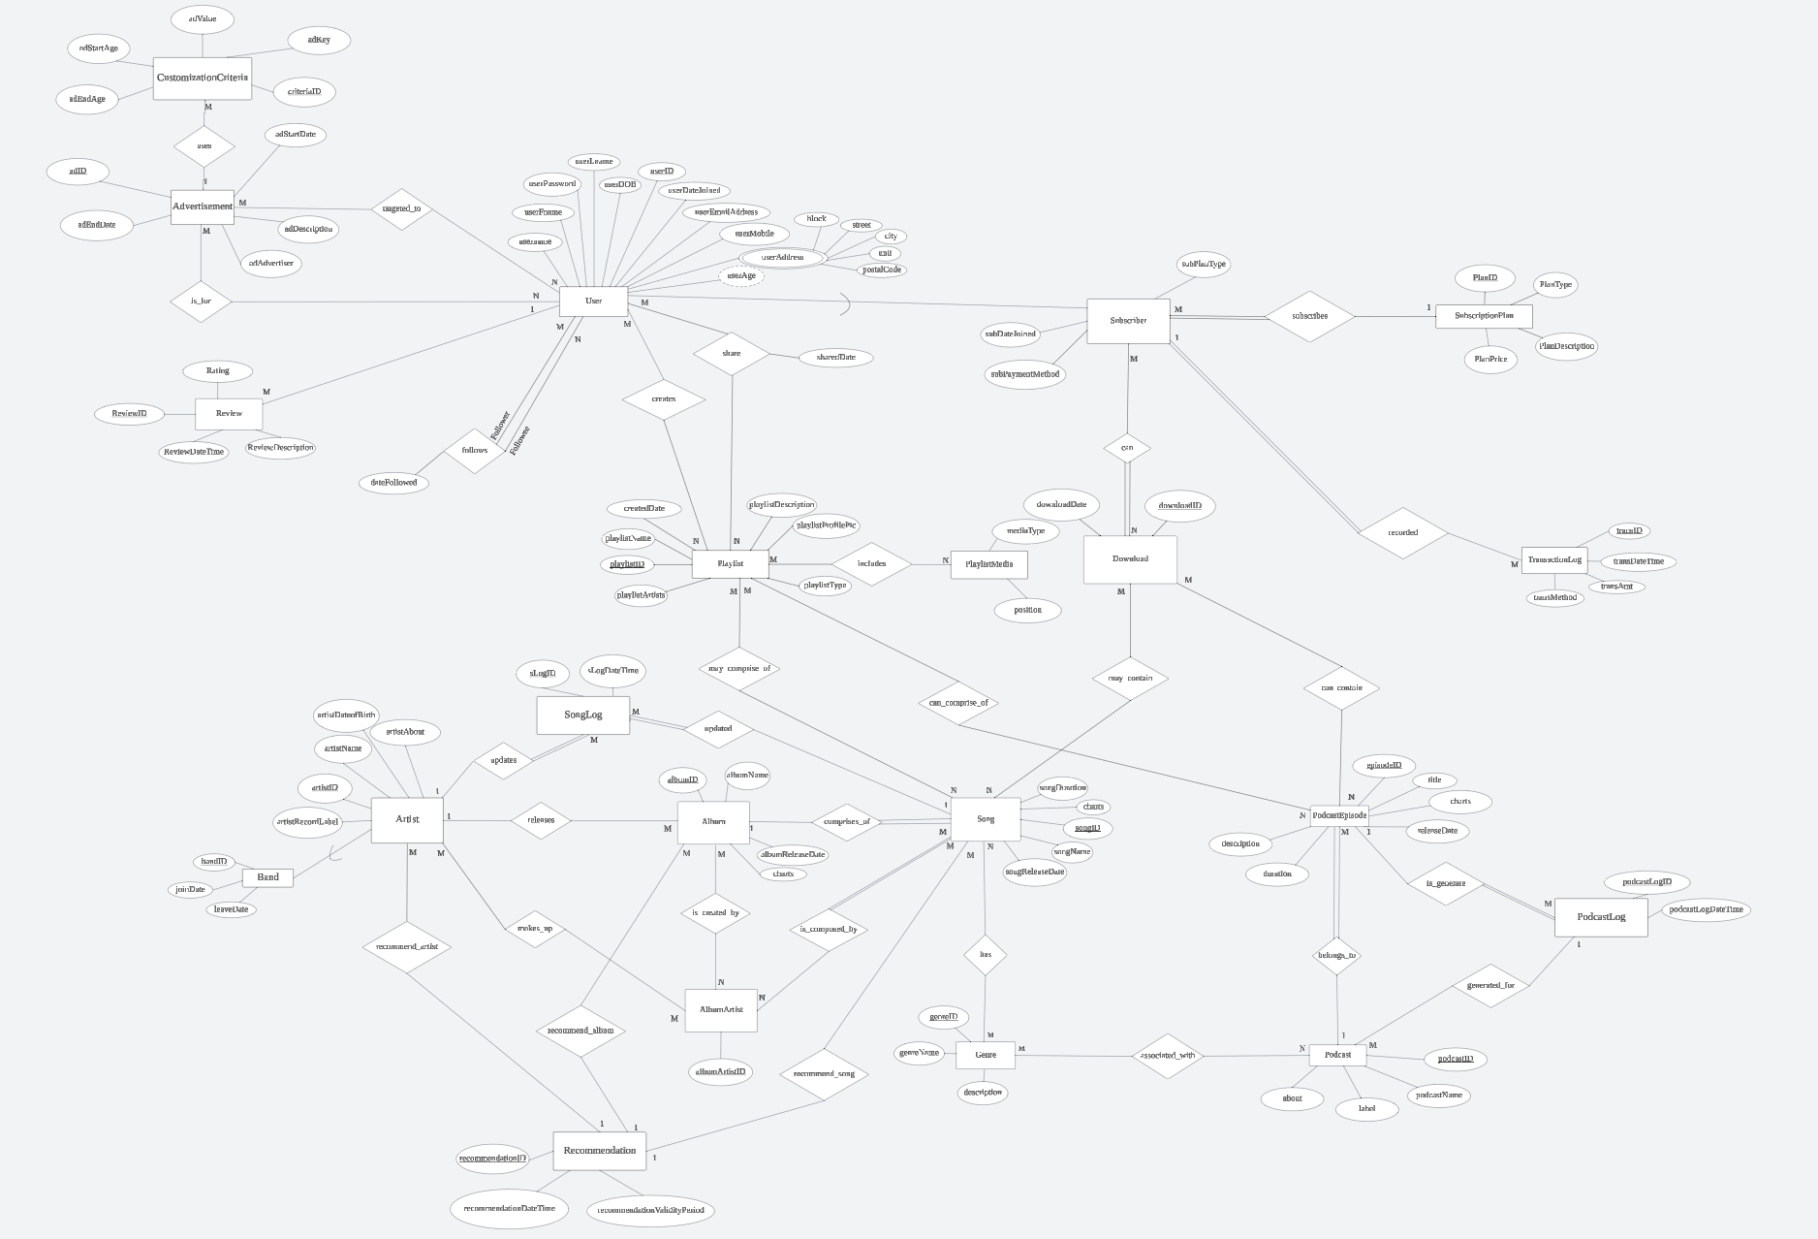

Refer to the attached PDF for clearer ER Model.

## Mapped Relations

1. Advertisement (adID, adDescription, customizationCriteria, adStartDate, adEndDate, <userID>)
2. Album (albumID, albumName, albumReleaseDate, charts, <genreID>)
3. AlbumArtist(albumArtistID,<albumID>,<songID>,<artistID>)
4. AlbumDenormalised(albumID, albumName, albumReleaseDate, charts, <genreID>, albumArtistID, <songID>,<artistID>)
5. Artist (artistID, artistName, artistDateofBirth, artistMonthlyListeners, artistRecordLabel)
6. ArtistDenormalised(artistID,artistName,artistDateofBirth,artistAbout,bandID,memberID,joinDate,leaveDate)
7. Band (bandID, joinDate, leaveDate)
8. Download (downloadID, downloadDate, <subID>, <podcast ID>, <episodeID>, <songID>)
9. Follower (userID, dateFollowed, <followerID>)
10. Genre (genreID, genreName, description)
11. Playlist (playlistID, playlistName, playlistDescription, playlistProfilePic, playlistType, playlistDuration, <playlistArtist>)
12. PlaylistSharing (<userID>, <playlistID>, sharedDate)
13. Podcast (podcastID, podcastName, about, label, monthlyListeners, <genreID>)
14. PodcastEpisode (episodeID, title, description, durationReleaseDate, noOfListens, charts, <podcastID>)
15. PodcastLog(podcastLogID, podcastLogDateTime, <podcastEpisodeID>, <podcastID>)
16. Review(reviewID, Rating, ReviewDateTime, ReviewDescription, <userID>)
17. Song (songID, songName, songReleaseDate, songDuration, charts, <albumID>, <genreID>)
18. SongDenormalised (songID, songName, songReleaseDate, songDuration, charts, <genreID>, <artistID>, <albumID>,<albumArtistID>)
19. SongLog(sLogID, sLogDateTime, <artistID>, <songID>)
20. Subscriber (<subID>, subDateJoined, subPaymentMethod, <planID>)
21. SubscriptionPlan (planID, planType, planDescription, planPrice)
22. User (userID, username, userFname, userLname, userPassword, userDOB, userEmailAddress, userAddress userDateJoined, userMobile, <countryCode>)
23. UserCountry (userID, username, userFname, userLname, userPassword, userDOB, userListenDuration, userDateJoined, userAddress, userEmailAddress, userMobile, userProfilePic, <countryCode>, countryName, currency)
24. SubscriberNormalised (<subID>, subDateJoined, subPaymentMethod, <planID>, planType, planDescription, planPrice)
25. TransactionLog (transID, transMethod, transAmt, transDateTime, <subID>)
26. DenormalizedPodcast (podcastID, podcastName, about, label, genreName, genreDescription)
27. Reccomedation(reccomendationID, reccomendationDateTime,reccomendationValidityPeriod)
28. ReccomendationDenormalized((reccomendationID,reccomendationDateTime,reccomendationValidityPeriod,artistName,songName,albumName)

# How your cloud database design meets the requirements of the entire system

Musify is a media-service company which provides an audio streaming platform to its millions of customers around the world. **Polyglot persistence** is a concept that involves employing diverse data storage methods and technologies to accommodate the distinct storage needs of various data types found within enterprise applications.

Several reasons for performing Polyglot persistence, which are:

1. **Data Separation**

Different types of data may have different structures, access patterns, and requirements. By storing them in separate databases, you can maintain a clear separation between different data sets, making it **easier to manage and maintain.**

1. **Scalability**

Different databases may have different scalability characteristics. For example, some databases are optimized for read-heavy workloads, while others may be better suited for write-intensive operations. By using databases that align with the specific needs of your application, you can achieve **better scalability**.

1. **Performance Optimization**

Different data storage technologies excel in specific performance aspects. Polyglot persistence enables Musify to leverage the strengths of each database for performance-critical scenarios. For example, using a highly performant in-memory database for real-time analytics and a distributed, scalable database for user profiles.

1. **Security**

Different types of data may require different levels of security. Storing sensitive data in a dedicated database with strict access controls can help enhance security and prevent unauthorized access.

1. **Data backup and recovery**

By storing data in different databases, backup and recovery strategies can be implemented based on the criticality and importance of each data set. This enables the prioritization of backup and recovery initiatives tailored to the unique requirements of each respective database.

1. **Isolation failure**

If a failure occurs in one database, it may not affect the others if they are independent. This isolation can help prevent a single point of failure from impacting the entire system.

Musify, an account-based system. In this system, users log into their accounts, gaining access to personalized music recommendations, playlists, and podcasts. The decision to opt for cloud database over a traditional SQL database is motivated by the need for continuous availability of data. Musify relies on a NoSQL approach, adhering to the **BASE** properties, where 'BA' stands for **B**asic **A**vailability, 'S' stands for the Soft state, and 'E' represents **E**ventually Consistent.

The choice of NoSQL is driven by the imperative of maintaining **Basic Availability**, ensuring uninterrupted access to user accounts despite potential system failures. NoSQL databases, through data spreading and replication across cluster nodes, guarantee the availability of user data. Additionally, the scalability inherent in NoSQL architectures facilitates the mitigation of significant usage spikes at any given time. This strategic implementation supports Musify in delivering a seamless and consistently accessible user experience.

Additionally, the potential surge in Musify's user activity necessitates a scalable database system capable of accommodating increased demand seamlessly. Efficient management of substantial data volumes at elevated velocities is imperative for Musify. Leveraging NoSQL, the system duplicates and stores data across diverse servers, ensuring heightened availability and reliability. Notably, Musify extends offline access to its subscribers through song and podcast downloads, enhancing the user experience.

1. **Evidence (screenshots) of implementation of cloud storages (in Microsoft Azure or local environment)**

**Implementation of Genre Storage**

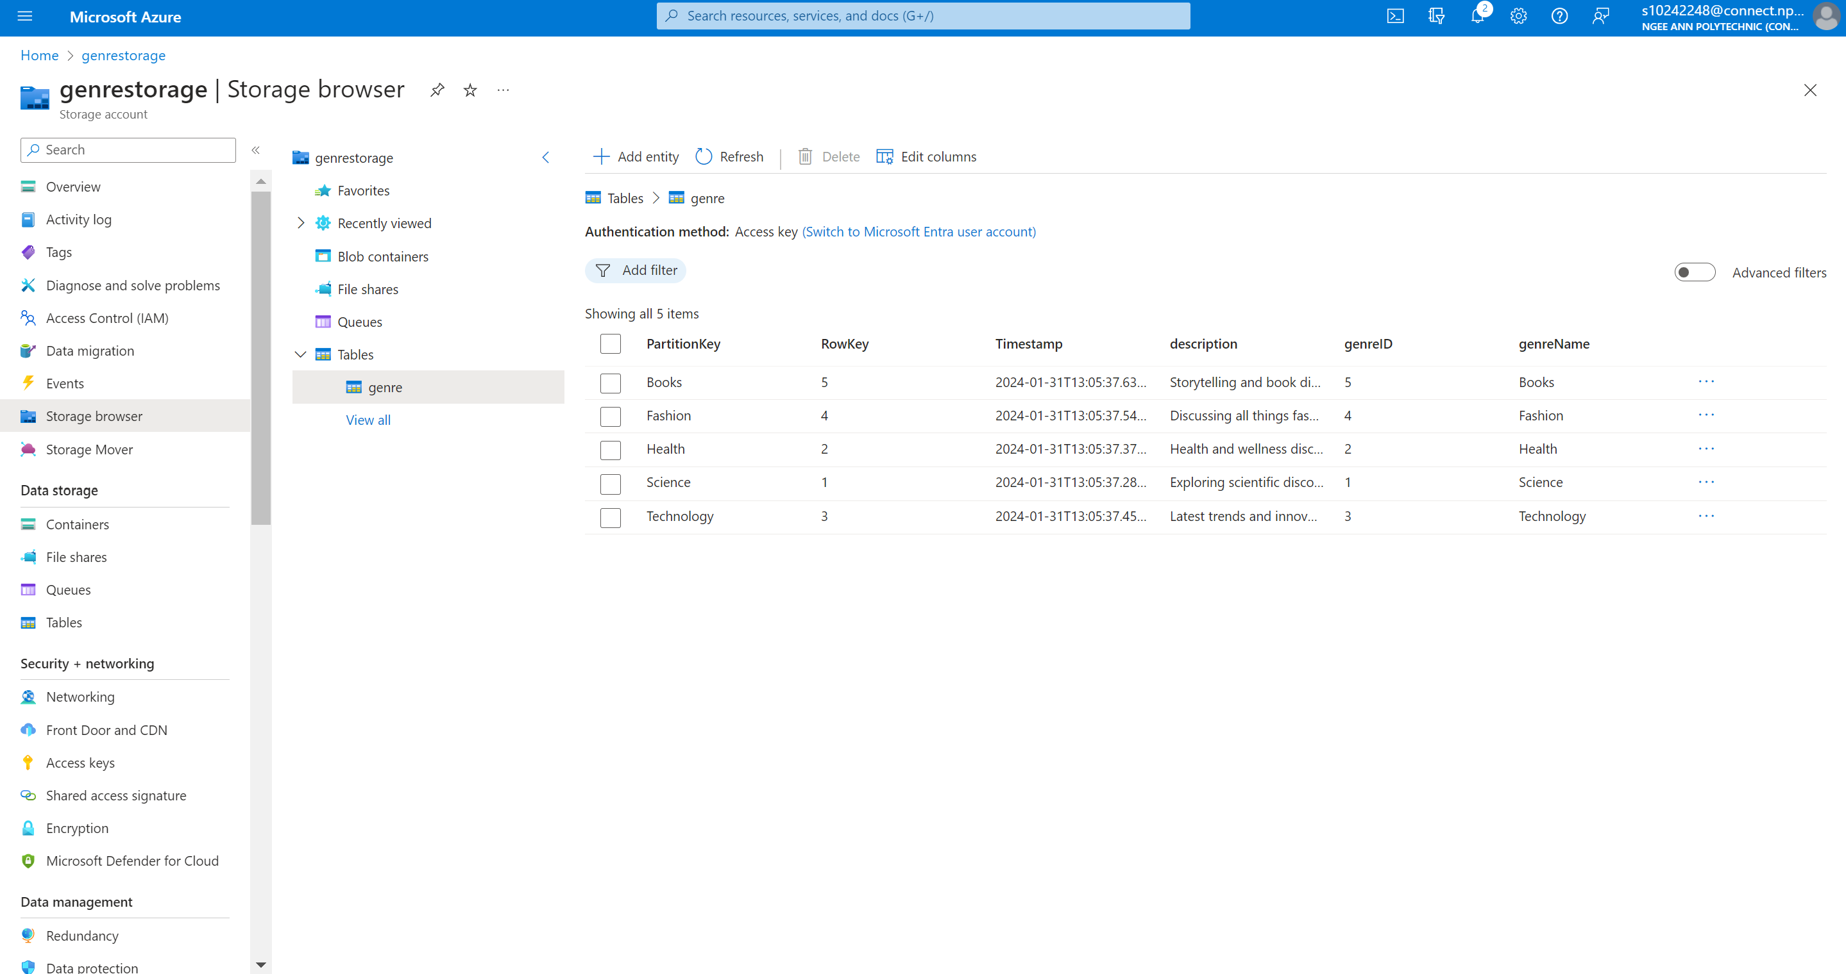

The image above shows the successful implementation of the genre table with Azura.

**Implementation of Podcast Table**



The image above shows the successful implementation of the podcast table with Azura.

**Implementation of PodcastEpisode Storage**

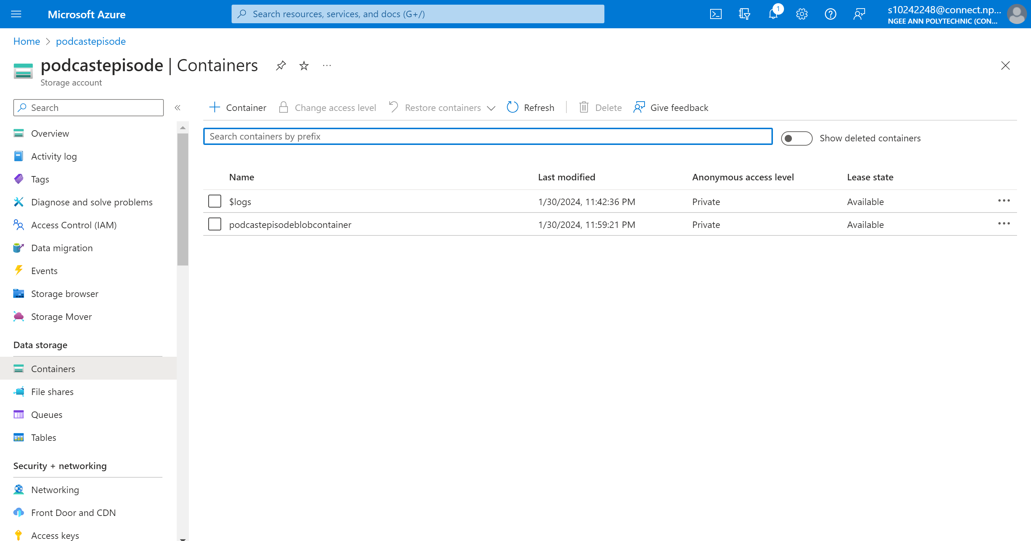

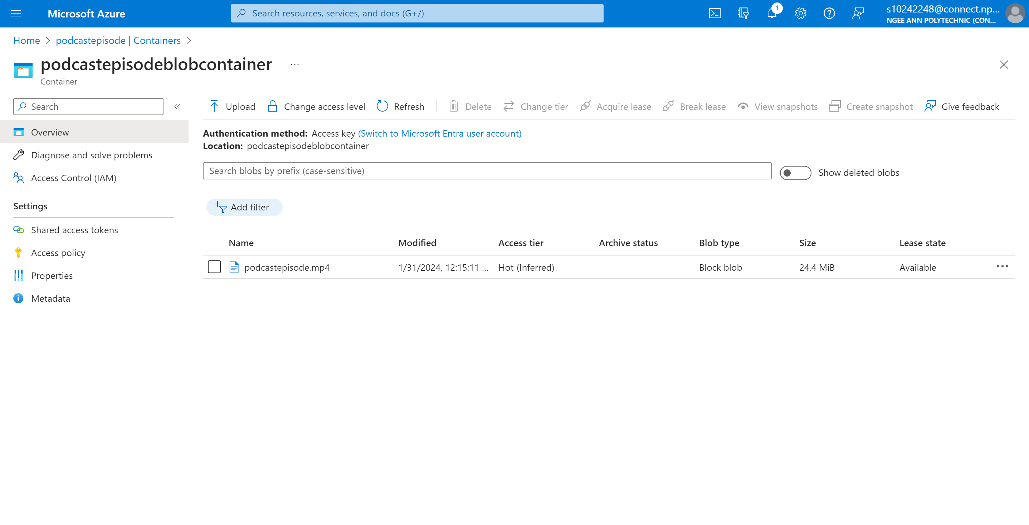

The images above shows the successful implementation of the podcastepisdode blob container with Azura.

**Implementation of PodcastLog Storage**

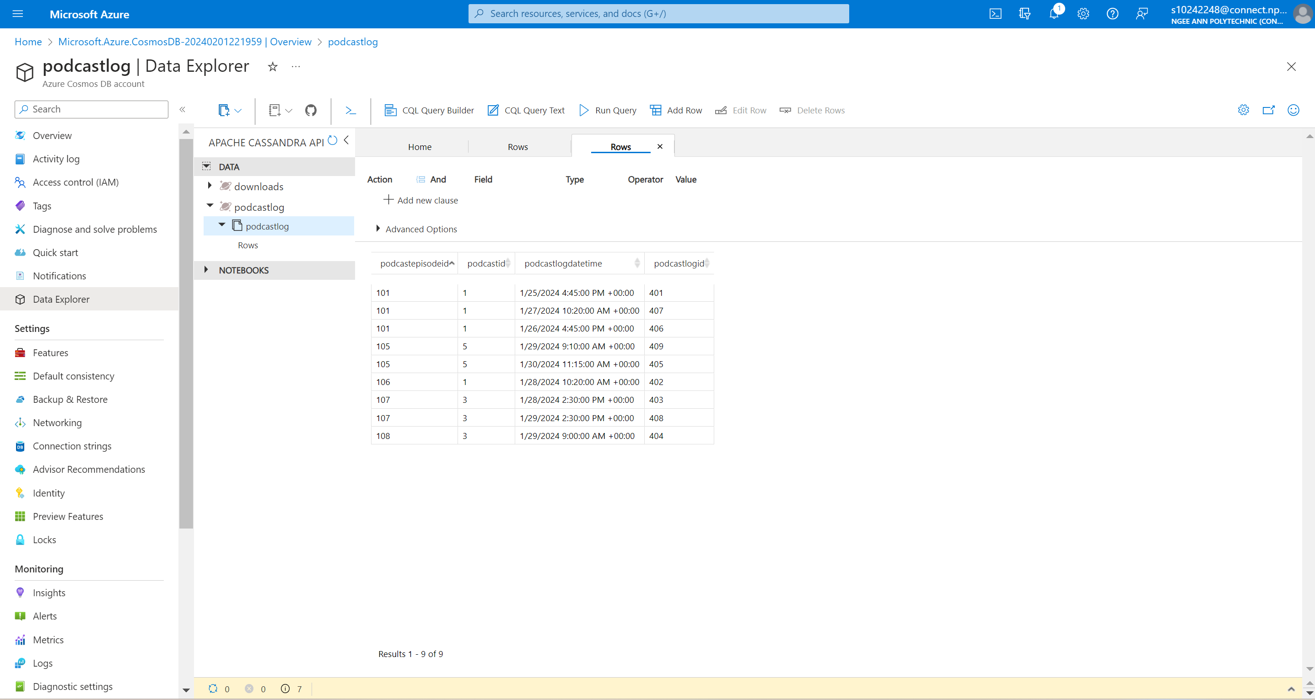

The image above shows the successful implementation of podcastlog columnar storage with Cassandra with Azura.

**Implementation of Download Storage**

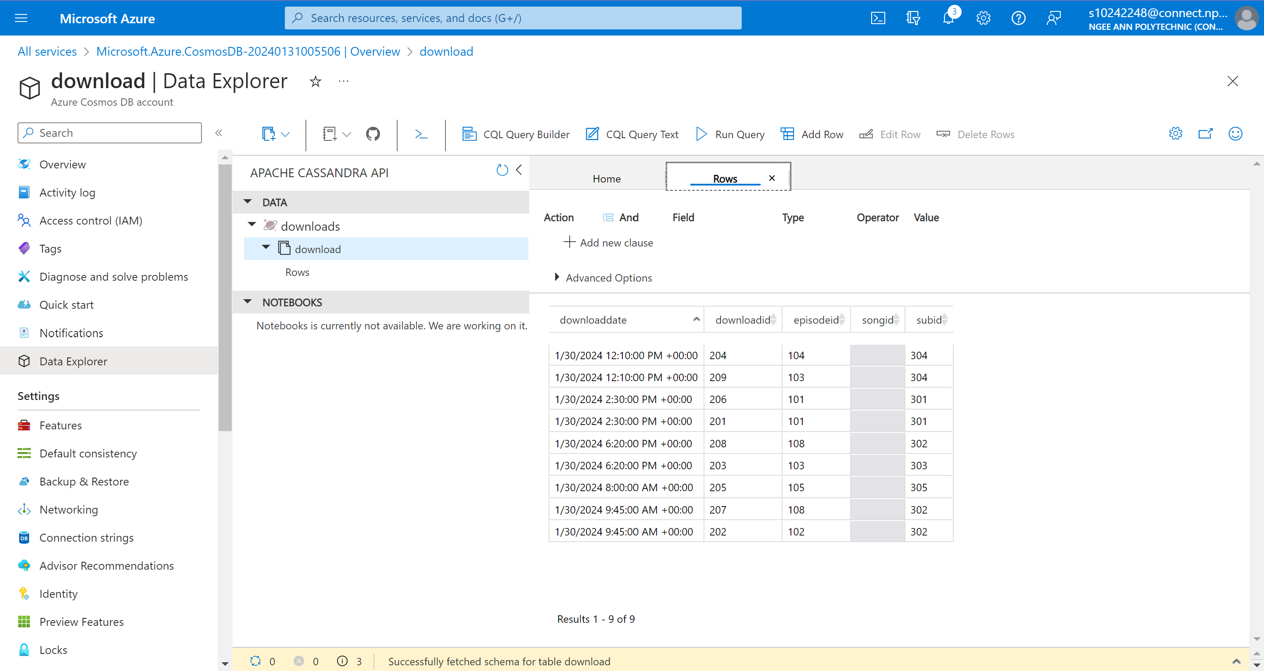

The image above shows the successful implementation of download columnar storage with Cassandra with Azura.

**Implementation of Review Storage**

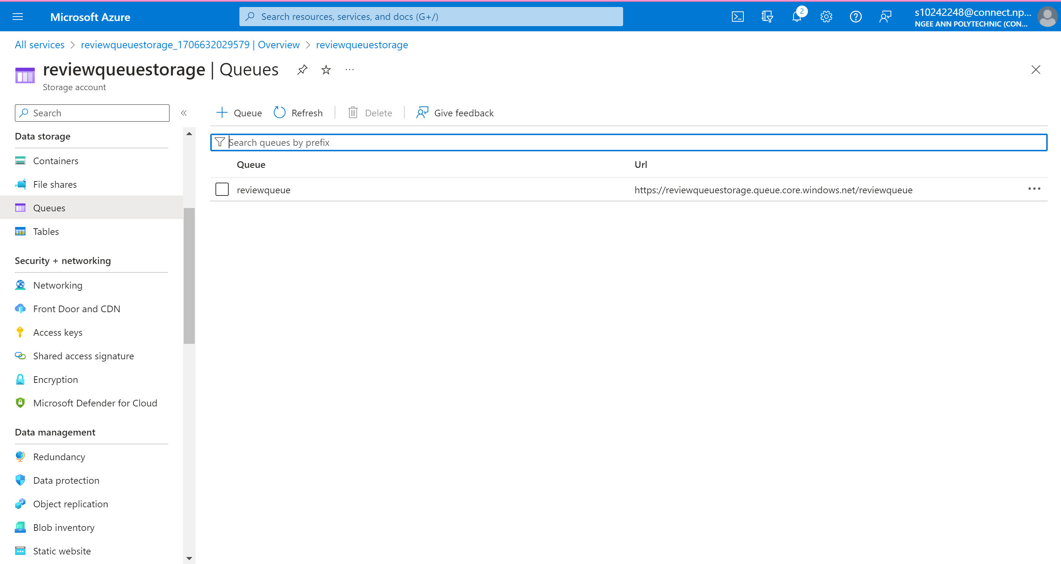

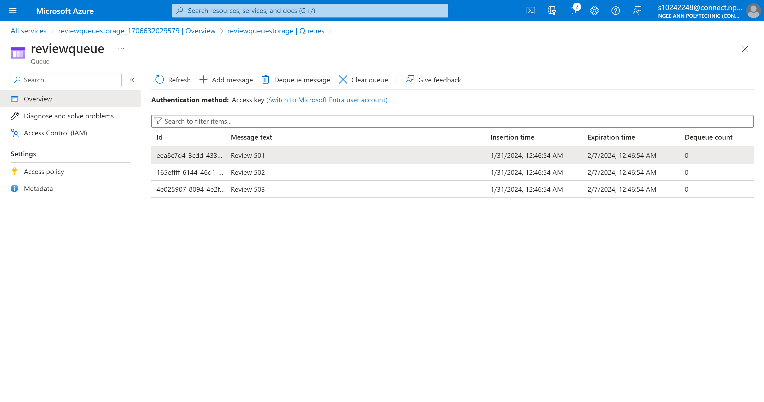

The images above show the successful implementation of review queue storage with Azura.

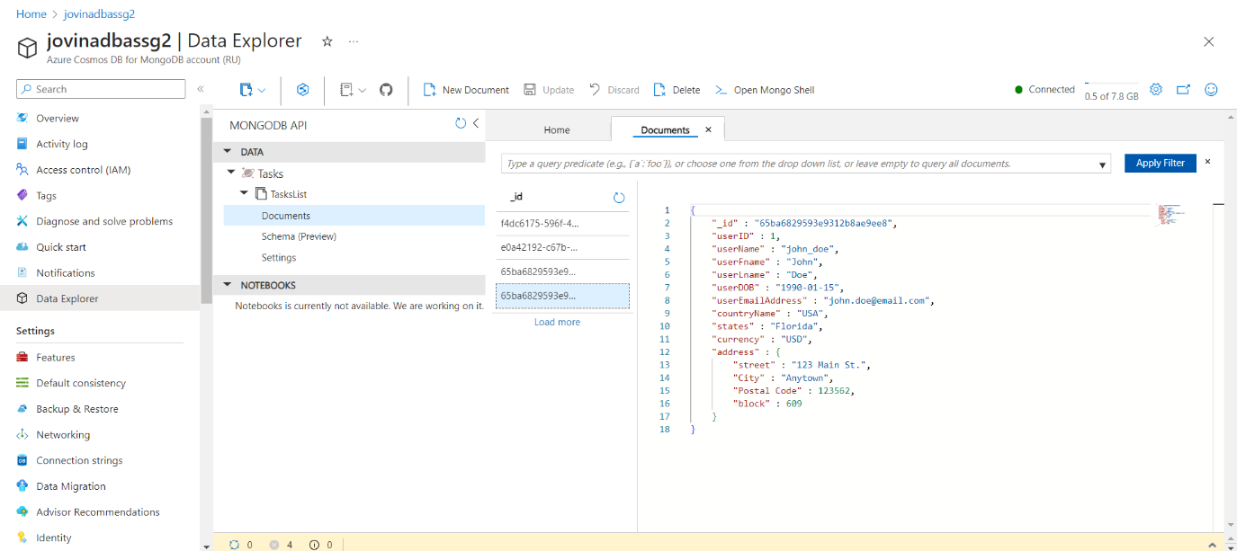

Document Database implemented for the userCountry table.

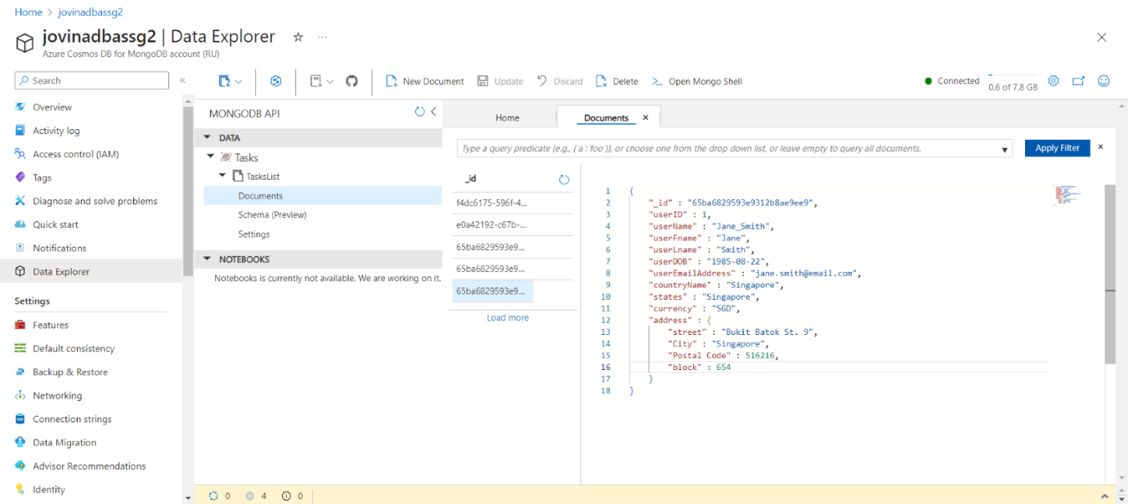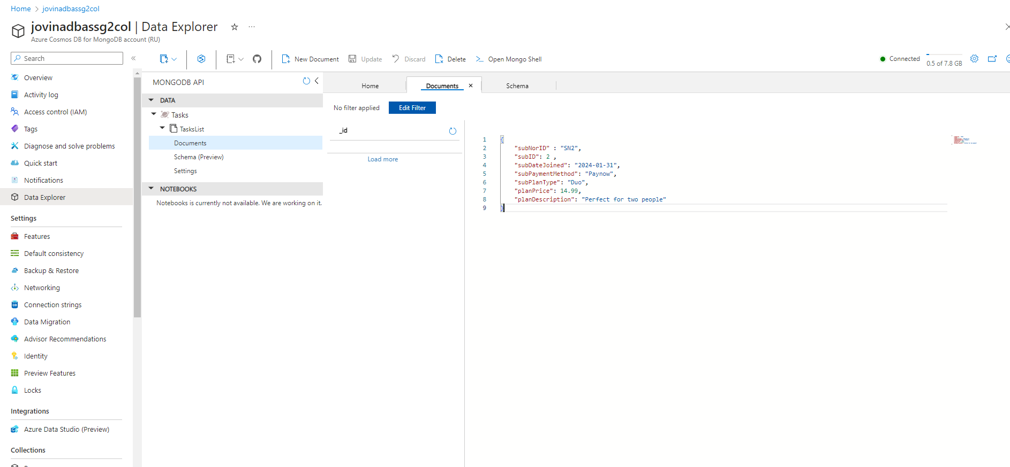

Document database implemented for the subscriberNormalised table.

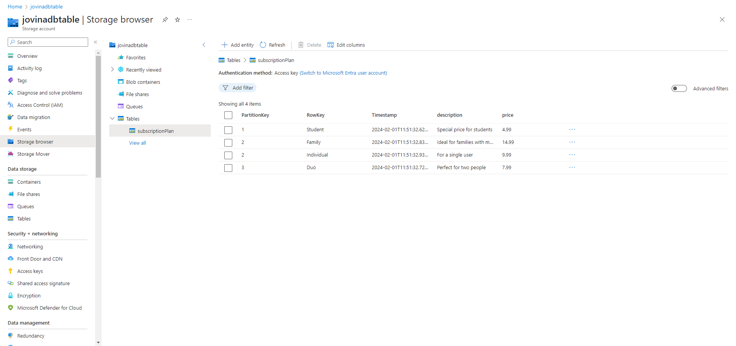

This is the azure table storage database that was implemented for the SubscriptionPlan table

# Tables

## Amelia

### Genre Table

**Cloud storage Strategies**

In the realm of music streaming platforms like Musify, the choice of Azure Table Storage for managing genre information emerges as a strategic decision with several compelling advantages. Azure Table Storage, designed around a key-value store paradigm, offers unique benefits tailored to the dynamic and diverse landscape of music genres.

Flexible Schema Design:

One of the paramount advantages of Azure Table Storage is its support for flexible schema design. In the vibrant world of music, where genres evolve, and new classifications emerge, having the ability to adapt swiftly is crucial. Azure Table Storage accommodates this dynamism, allowing Musify to seamlessly introduce new genres, update metadata, and adjust structures without the constraints of a rigid schema.

Efficient Key-Value Model:

Azure Table Storage's key-value model proves instrumental in ensuring quick and low-latency access to individual genres based on their primary key, such as "genreID" in the context of Musify. This expeditious retrieval is fundamental for applications like Musify, enabling swift access to specific genres, aligning with user preferences, or facilitating efficient search functionality.

Horizontal Scalability:

Music streaming platforms experience variable workloads due to changing user engagement patterns or promotional events. Azure Table Storage excels in horizontal scalability, automatically adapting to fluctuating workloads and efficiently managing increased traffic. This scalability feature ensures Musify's ability to handle diverse user interactions seamlessly.

Managed Service Advantage:

Azure Table Storage being a managed service significantly simplifies operational aspects for Musify. With Azure handling infrastructure and maintenance tasks, Musify can concentrate on refining its music streaming service, ensuring a robust and reliable platform for users. This managed service approach streamlines administrative efforts and contributes to a more focused and efficient development process.

In conclusion, adopting Azure Table Storage for storing genre information in Musify proves to be an astute choice. The combination of flexible schema design, efficient key-value access, horizontal scalability aligns seamlessly with the dynamic nature of music genres, ultimately enhancing the performance and user experience of Musify.

**Design**

The provided C# code demonstrates how to interact with Azure Table Storage using the Azure.Data.Tables namespace. It includes the creation of a TableClient and the insertion of records into an Azure table.

using Azure.Data.Tables;

using genretable;

using System.Security.Principal;

// New instance of the TableClient class

TableServiceClient tableServiceClient =

new TableServiceClient("DefaultEndpointsProtocol=https;AccountName=genrestorage;AccountKey=SdBJseWDuQNdo43eQH8MqXanWqHD6TncvtnuIVEfkbfJd1NJB/zKPEQTs5I5ciU3JzHBcH329MX8+AStr8repw==;EndpointSuffix=core.windows.net");

// New instance of TableClient class referencing the server-side table

TableClient tableClient = tableServiceClient.GetTableClient(tableName:"genre");

await tableClient.CreateIfNotExistsAsync();

// Create new item using composite key constructor

var genre1 = new Genre

{

PartitionKey = "Science",

RowKey = "1",

genreID = 1,

genreName = "Science",

description = "Exploring scientific discoveries and topics"

};

// Create new item using composite key constructor

var genre2 = new Genre

{

PartitionKey = "Health",

RowKey = "2",

genreID = 2,

genreName = "Health",

description = "Health and wellness discussions"

};

var genre3 = new Genre

{

PartitionKey = "Technology",

RowKey = "3",

genreID = 3,

genreName = "Technology",

description = "Latest trends and innovations in technology"

};

var genre4 = new Genre

{

PartitionKey = "Fashion",

RowKey = "4",

genreID = 4,

genreName = "Fashion",

description = "Discussing all things fashion"

};

var genre5 = new Genre

{

PartitionKey = "Books",

RowKey = "5",

genreID = 5,

genreName = "Books",

description = "Storytelling and book discussions"

};

// Add new item to server-side table

await tableClient.UpsertEntityAsync<Genre>(genre1);

await tableClient.UpsertEntityAsync<Genre>(genre2);

await tableClient.UpsertEntityAsync<Genre>(genre3);

await tableClient.UpsertEntityAsync<Genre>(genre4);

await tableClient.UpsertEntityAsync<Genre>(genre5);

using Azure.Data.Tables;

using Azure;

using System;

using System.Collections.Generic;

using System.Linq;

using System.Text;

using System.Threading.Tasks;

namespace genretable

{

internal class Class1

{

}

// C# record type for items in the table

public record Genre : ITableEntity

{

public string PartitionKey { get; set; } = default!;

public string RowKey { get; set; } = default!;

public int genreID { get; init; }

public string genreName { get; init; } = default!;

public string? description { get; init; }

public ETag ETag { get; set; } = default!;

public DateTimeOffset? Timestamp { get; set; } = default!;

}

}

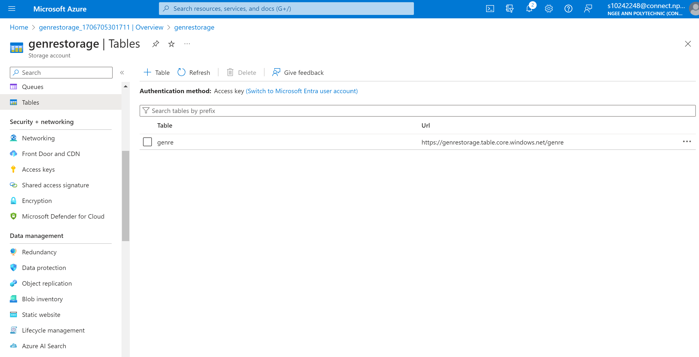

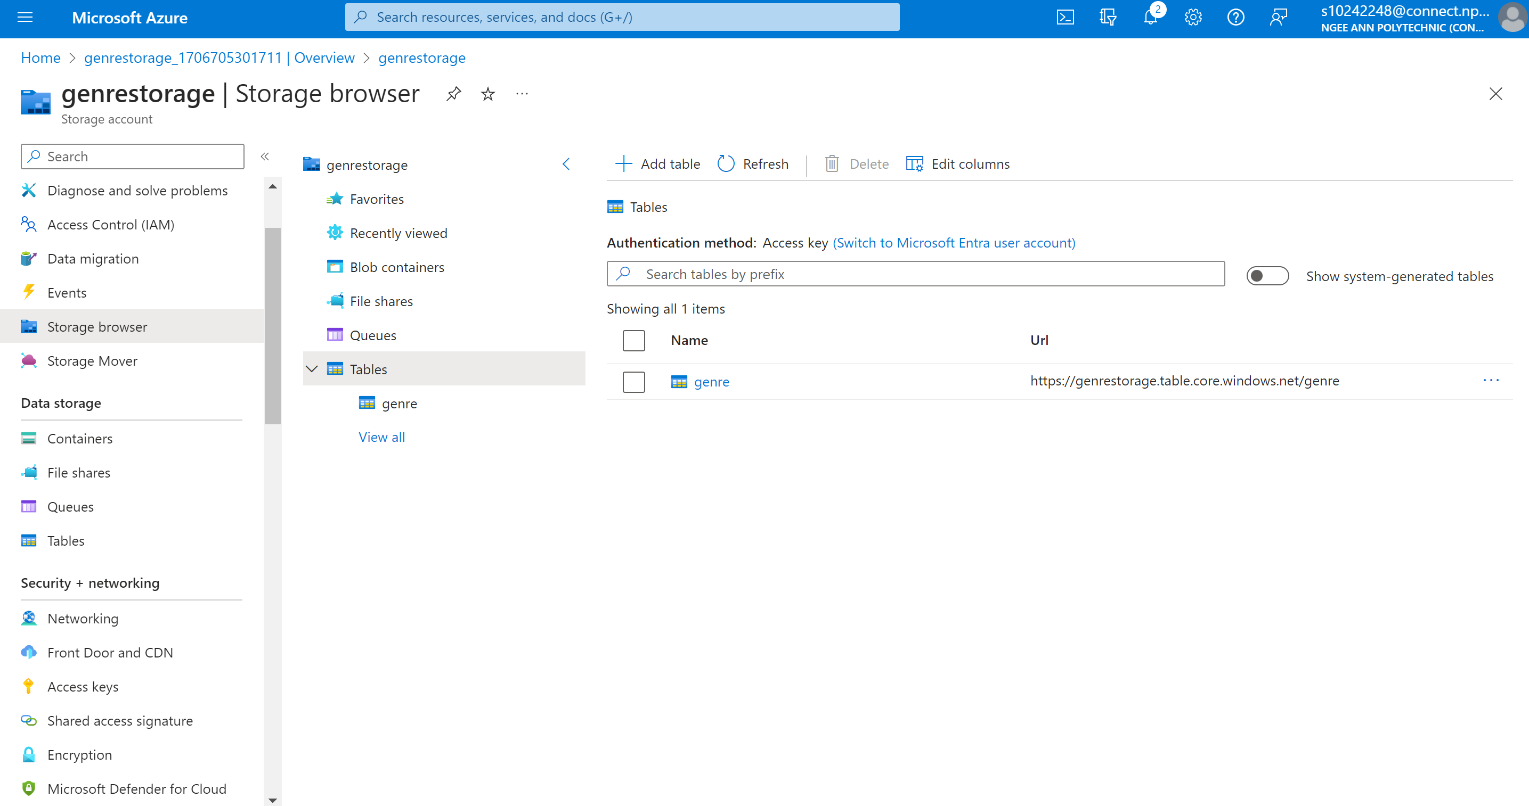



### Podcast Table

**Denormalization**

In the original schema, there's a separate Genre table and a Podcast table linked by a foreign key (genreID). Each podcast can belong to multiple genres, establishing a many-to-many (M:N) relationship.

Genre to Podcast relationship (M: N)

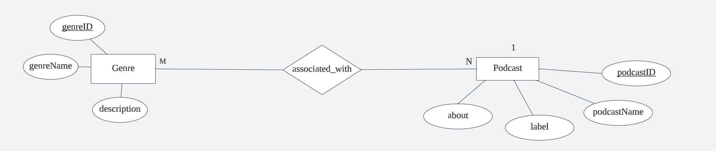

**Before:**

Genre Table

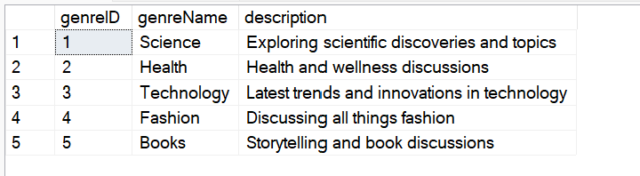

Genre (genreID, genreName, description)

Podcast Table

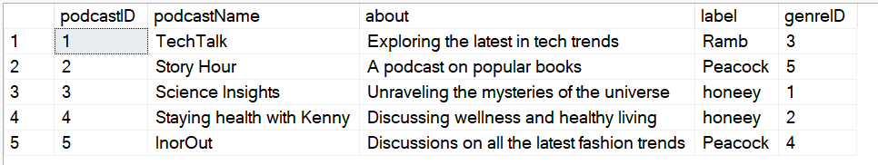Podcast (podcastID, podcastName, about, label, <genreID>)

**After:**

Denormalized Podcast Table

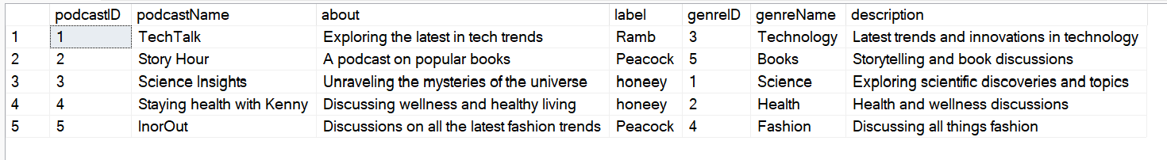DenormalizedPodcast (podcastID, podcastName, about, label, genreName, genreDescription)

In the denormalized structure, we've included additional columns (genreName and genreDescription) directly in the Podcast table. This means that information about the genre is duplicated for each podcast, eliminating the need for multiple joins when querying.

**Queries**

Old

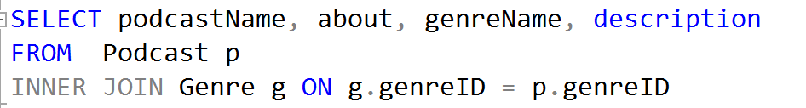

New



Denormalizing my genre table into my podcast table offers a multifaceted enhancement to database performance.

Firstly, it lowers the need for joins, which significantly improves query performance. This acceleration in data retrieval is especially important in commercial contexts where quick access to information is essential for making timely decisions.

Second, by adding genre information directly into the Podcast table, denormalization reduces computational overhead. This is especially important when it comes to computing resources.

Denormalization offers efficient data retrieval using fewer database resources while prioritizing resource optimization. Furthermore, denormalized structures help to simplify development and maintenance by resulting in more straightforward database schemas.

**Data Placement Strategies**

In structuring the Podcast table within Azure Table Storage, adopting row partitioning organized by genre proves to be an advantageous data placement strategy, particularly when compared to having no partitioning at all. This approach significantly enhances query performance and improves the overall user experience, especially for users seeking to browse or search for podcasts based on their genre preferences.

Efficient Query Performance:

Row partitioning by genre allows for efficient retrieval of podcasts based on their genre, a stark improvement over having no partitioning. In scenarios without partitioning, queries would typically involve scanning through all podcasts, leading to increased processing time and resource consumption. The partitioning structure narrows down the search scope to a specific genre, reducing the amount of data that needs to be scanned or filtered, resulting in superior query performance.

Improved Scalability:

Furthermore, row partitioning not only aids in query performance but also contributes to enhanced scalability, a crucial factor absent in a scenario with no partitioning. Without partitioning, the absence of data distribution across multiple partitions might lead to concentrated traffic on specific parts of the dataset, potentially causing performance bottlenecks. Row partitioning ensures a balanced distribution of data, preventing hotspots and promoting a more scalable system.

Logical Organization:

Additionally, grouping podcasts by genre in row partitions aligns with a logical organization of the data, providing a structured approach that is lacking in a scenario without partitioning. The absence of partitioning might result in a less intuitive organization for queries based on genre, making it challenging for users to efficiently access podcasts within their preferred genres.

User-Friendly Experience:

In summary, row partitioning by genre in the Podcast table stands out as a superior strategy when compared to having no partitioning. It not only addresses the specific needs of users seeking podcasts based on genre preferences but also significantly improves query performance, scalability, and the overall logical organization of data. This approach provides a more streamlined and user-friendly experience within the Azure Table Storage environment, aligning with the evolving demands of podcast applications.

Before partitioning

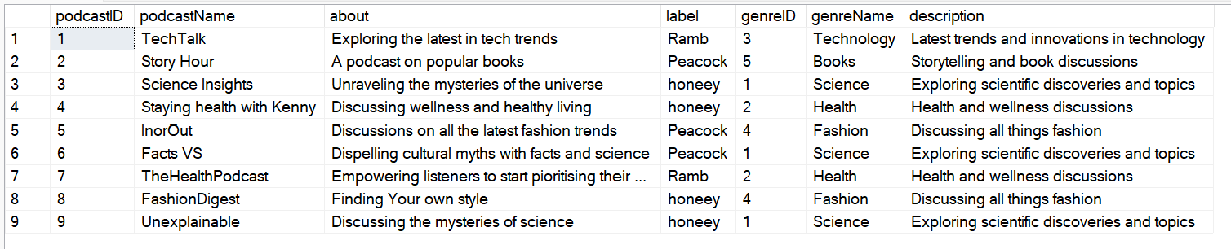

After Partitioning







**Cloud storage strategies**

In the realm of podcast storage within Azure Table Storage, the adoption of a key-value store architecture, exemplified by Azure Table Storage, emerges as a strategic choice offering numerous advantages for businesses, particularly those seeking to efficiently manage extensive and diverse podcast datasets. The distinctive features of Azure Table Storage cater to the dynamic nature of podcasts, accommodating varying attributes and structures, making it a robust solution for podcast platforms.

Flexible Schema Design:

One of the standout advantages of Azure Table Storage is its support for flexible schema design. This is especially crucial in the dynamic podcasting landscape where new genres, formats, and additional metadata are continually introduced. The flexibility allows podcast platforms to adapt swiftly, seamlessly incorporating new podcast attributes without the constraints of a rigid schema.

Efficient Key-Value Model:

Azure Table Storage's key-value model proves instrumental in ensuring swift and low-latency access to individual podcast items based on their primary key, such as the unique podcastID. This efficiency is paramount for applications requiring rapid retrieval of specific podcasts or genres, aligning seamlessly with user preferences and search queries.

Horizontal Scaling for Variable Workloads:

Azure Table Storage excels in horizontal scaling, automatically adjusting to variable workloads and efficiently handling increased traffic. This scalability feature is essential for podcast platforms experiencing fluctuations in user engagement or promotional events, ensuring consistent performance and responsiveness.

Row Partitioning by Genre:

A notable consideration for optimizing performance is the use of row partitioning in Azure Table Storage, specifically organized by genre. This strategic partitioning makes it easier to manage and retrieve podcasts within specific genres efficiently. Aligning with the natural querying patterns in podcast applications, where users often explore content within specific genres, this partitioning strategy enhances the overall user experience.

Managed Service Advantage:

Azure Table Storage operates as a managed service, simplifying operational aspects for businesses. With Azure managing infrastructure and maintenance tasks, organizations can dedicate their efforts to developing and enhancing their podcast platform. This managed service approach streamlines administrative efforts, contributing to a robust and reliable service for users.

In summary, adopting Azure Table Storage for podcast storage, particularly with a row partitioning strategy by genre, aligns seamlessly with the dynamic nature of podcast content. This approach not only enhances query performance but also provides scalability benefits, contributing to the development of a more efficient, scalable, and user-friendly podcast platform for businesses and their audiences.

**Design**

The provided C# code demonstrates how to interact with Azure Table Storage using the Azure.Data.Tables namespace. It includes the creation of a TableClient and the insertion of records into an Azure table.

using Azure.Data.Tables;

using Azure;

using System;

using System.Collections.Generic;

using System.Linq;

using System.Text;

using System.Threading.Tasks;

namespace podcasttablestorage

{

internal class Class1

{

}

public record Podcast : ITableEntity

{

public string PartitionKey { get; set; } = default!;

public string RowKey { get; set; } = default!;

public int PodcastID { get; set; }

public string PodcastName { get; set; } = default!;

public string? About { get; set; }

public string? Label { get; set; }

public int GenreID { get; set; }

public string GenreName { get; set; } = default!;

public string? Description { get; set; } = default!;

public ETag ETag { get; set; } = default!;

public DateTimeOffset? Timestamp { get; set; } = default!;

}

}

using Azure.Data.Tables;

using podcasttablestorage;

using System.Security.Principal;

// New instance of the TableClient class

TableServiceClient tableServiceClient =

new TableServiceClient("DefaultEndpointsProtocol=https;AccountName=podcasttable;AccountKey=1YrpEsZmDNyydmhydx4GIvC9nTejZqDJfSYl/Jz1mUnp3qoBrfHP4Z6dRViHfW2bK5Ug0H+UEEyT+ASt16nIbg==;EndpointSuffix=core.windows.net");

// New instance of TableClient class referencing the server-side table

TableClient tableClient = tableServiceClient.GetTableClient(tableName: "Podcasts");

await tableClient.CreateIfNotExistsAsync();

var podcast1 = new Podcast

{

PartitionKey = "Technology",

RowKey = "1",

PodcastID = 1,

PodcastName = "TechTalk",

About = "Exploring the latest in tech trends",

Label = "Ramb",

GenreID = 3,

GenreName = "Technology",

Description = "Latest trends and innovations in technology"

};

var podcast2 = new Podcast

{

PartitionKey = "Books",

RowKey = "2",

PodcastID = 2,

PodcastName = "Story Hour",

About = "A podcast on popular books",

Label = "Peacock",

GenreID = 5,

GenreName = "Books",

Description = "Storytelling and book discussions"

};

var podcast3 = new Podcast

{

PartitionKey = "Science",

RowKey = "3",

PodcastID = 3,

PodcastName = "Science Insights",

About = "Unraveling the mysteries of the universe",

Label = "honeey",

GenreID = 1,

GenreName = "Science",

Description = "Exploring scientific discoveries and topics"

};

var podcast4 = new Podcast

{

PartitionKey = "Health",

RowKey = "4",

PodcastID = 4,

PodcastName = "Staying health with Kenny",

About = "Discussing wellness and healthy living",

Label = "honeey",

GenreID = 2,

GenreName = "Health",

Description = "Health and wellness discussions"

};

var podcast5 = new Podcast

{

PartitionKey = "Fashion",

RowKey = "5",

PodcastID = 5,

PodcastName = "InorOut",

About = "Discussions on all the latest fashion trends",

Label = "Peacock",

GenreID = 4,

GenreName = "Fashion",

Description = "Discussing all things fashion"

};

var podcast6 = new Podcast

{

PartitionKey = "Science",

RowKey = "6",

PodcastID = 6,

PodcastName = "Facts VS",

About = "Dispelling cultural myths with facts and science",

Label = "Peacock",

GenreID = 1,

GenreName = "Science",

Description = "Exploring scientific discoveries and topics"

};

var podcast7 = new Podcast

{

PartitionKey = "Health",

RowKey = "7",

PodcastID = 7,

PodcastName = "TheHealthPodcast",

About = "Empowering listeners to start prioritizing their health",

Label = "Ramb",

GenreID = 2,

GenreName = "Health",

Description = "Health and wellness discussions"

};

var podcast8 = new Podcast

{

PartitionKey = "Fashion",

RowKey = "8",

PodcastID = 8,

PodcastName = "FashionDigest",

About = "Finding Your own style",

Label = "honeey",

GenreID = 4,

GenreName = "Fashion",

Description = "Discussing all things fashion"

};

var podcast9 = new Podcast

{

PartitionKey = "Science",

RowKey = "9",

PodcastID = 9,

PodcastName = "Unexplainable",

About = "Discussing the mysteries of science",

Label = "honeey",

GenreID = 1,

GenreName = "Science",

Description = "Exploring scientific discoveries and topics"

};

// Assuming you have a data access method (e.g., using Entity Framework, Dapper, etc.)

// Insert the podcasts into the NewPodcast table

await tableClient.UpsertEntityAsync<Podcast>(podcast1);

await tableClient.UpsertEntityAsync<Podcast>(podcast2);

await tableClient.UpsertEntityAsync<Podcast>(podcast3);

await tableClient.UpsertEntityAsync<Podcast>(podcast4);

await tableClient.UpsertEntityAsync<Podcast>(podcast5);

await tableClient.UpsertEntityAsync<Podcast>(podcast6);

await tableClient.UpsertEntityAsync<Podcast>(podcast7);

await tableClient.UpsertEntityAsync<Podcast>(podcast8);

await tableClient.UpsertEntityAsync<Podcast>(podcast9);

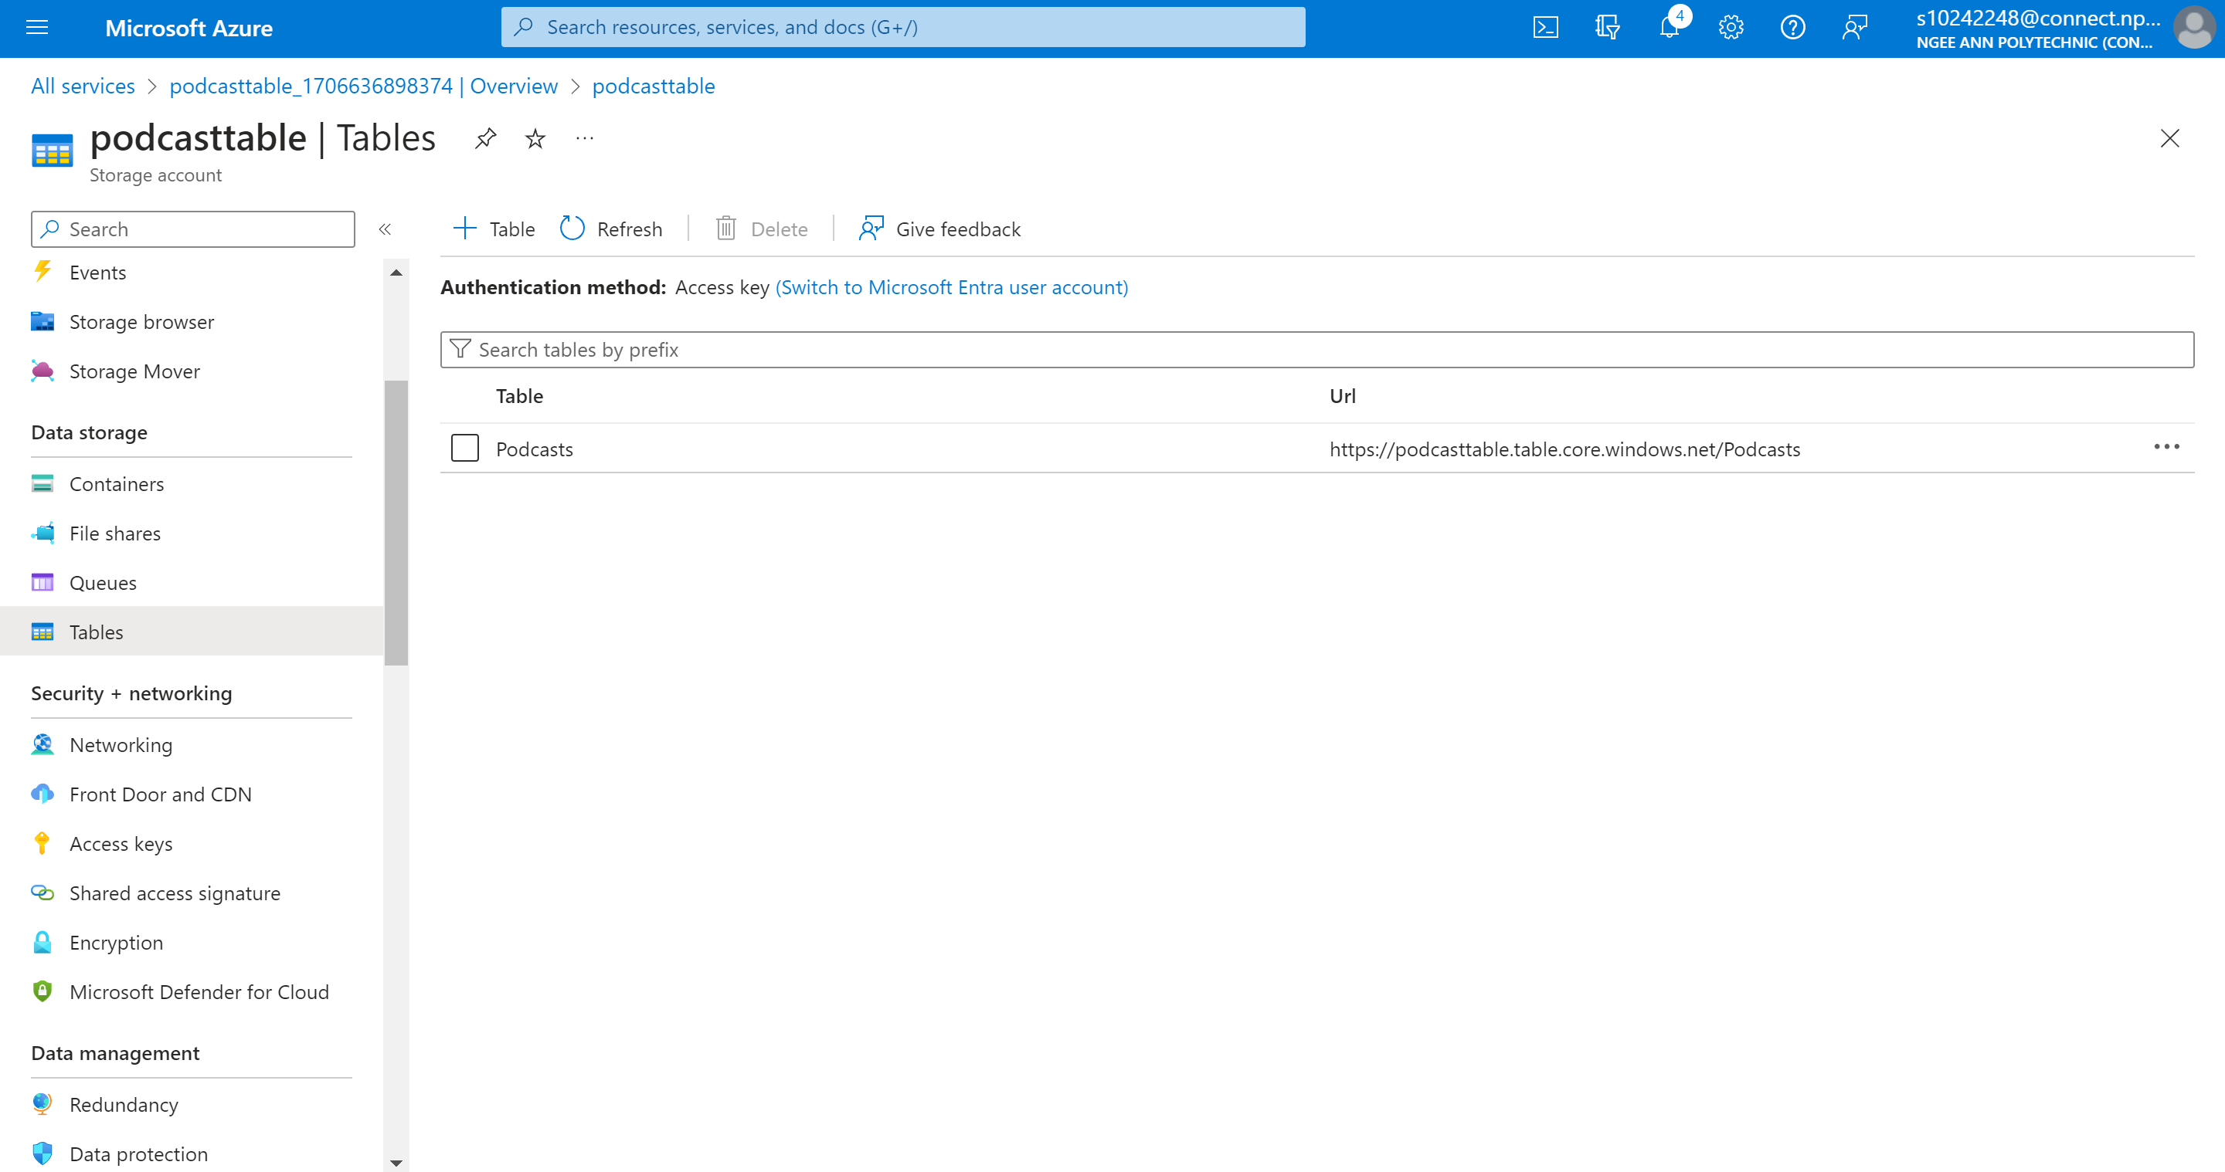

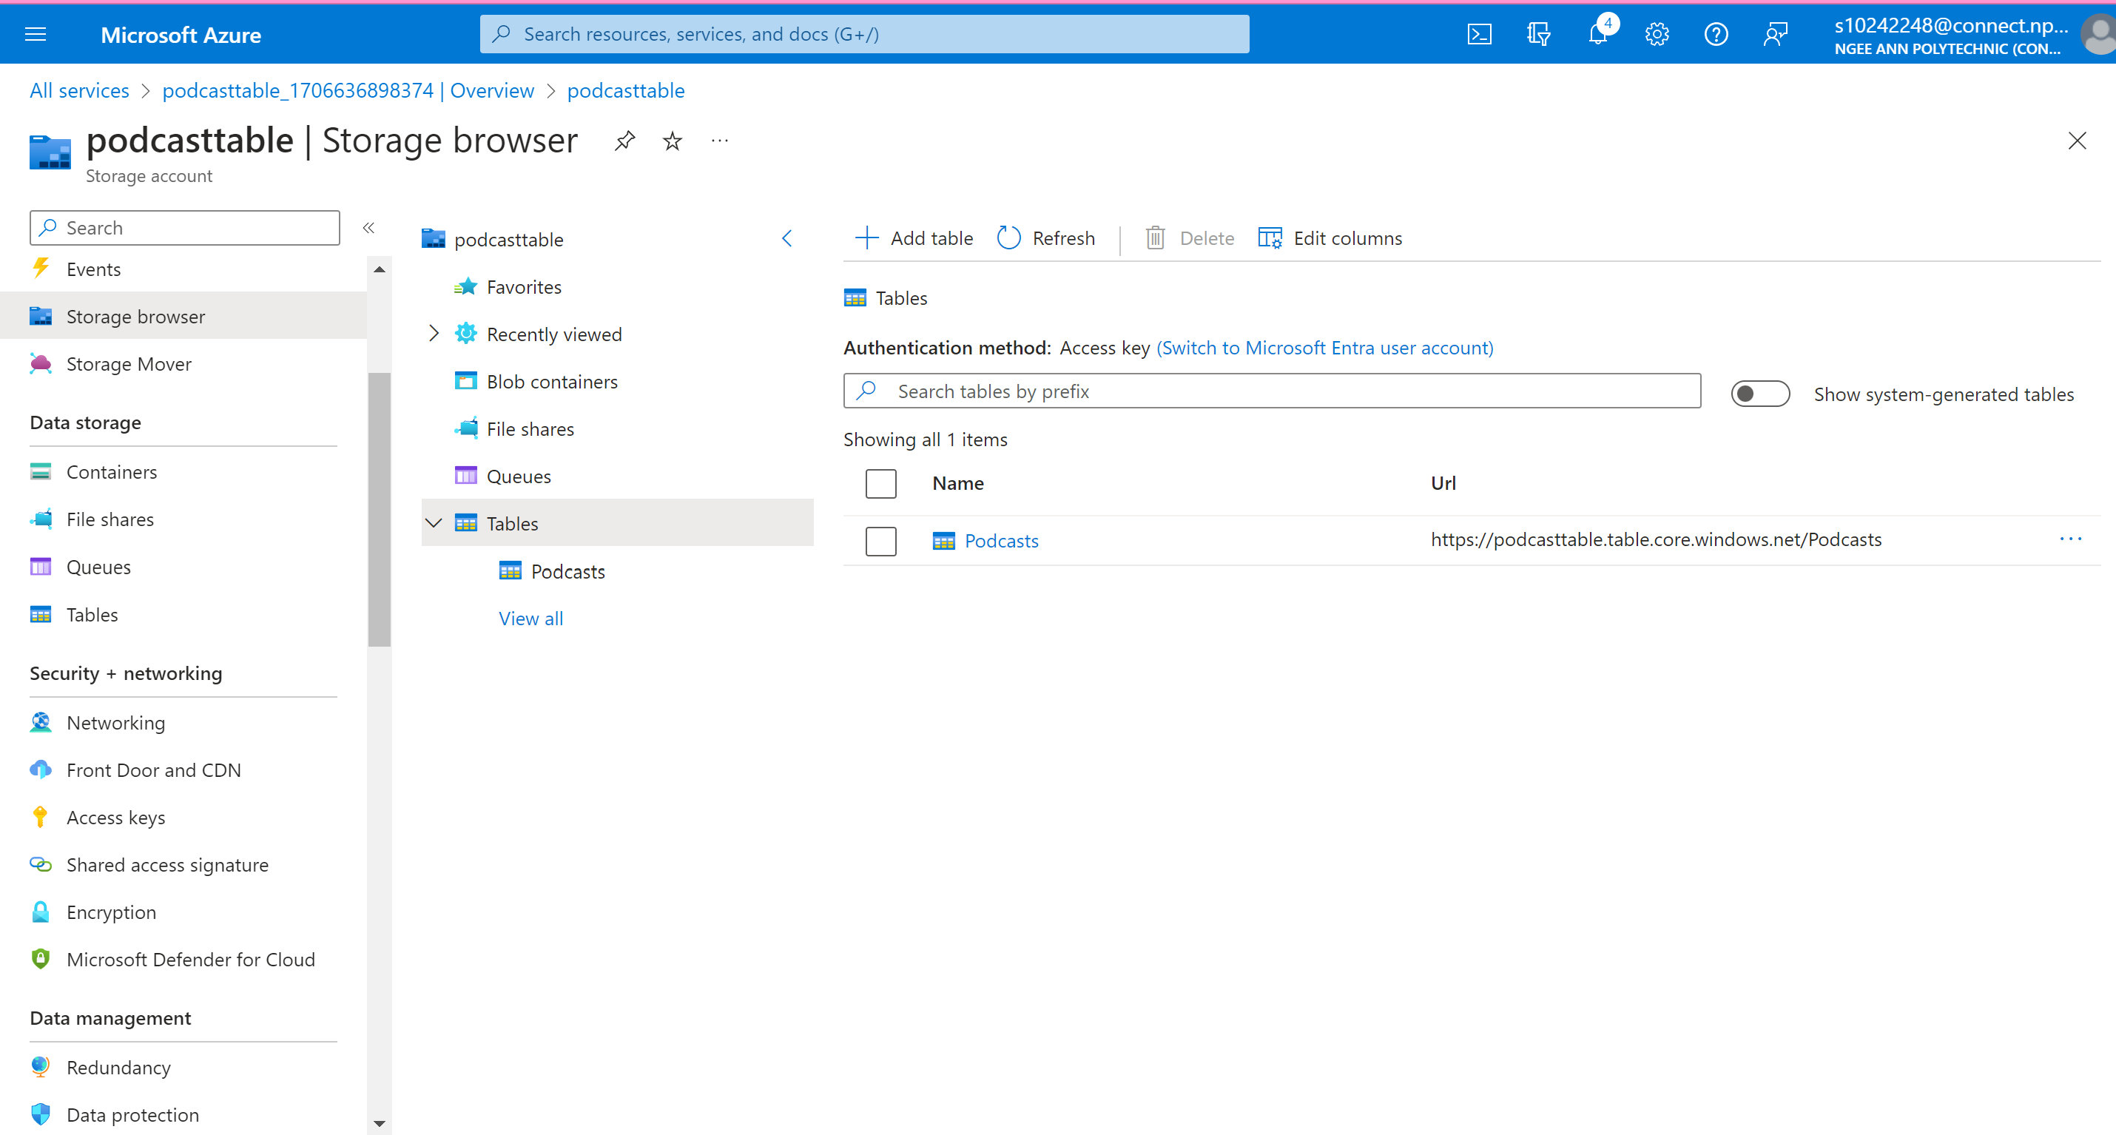

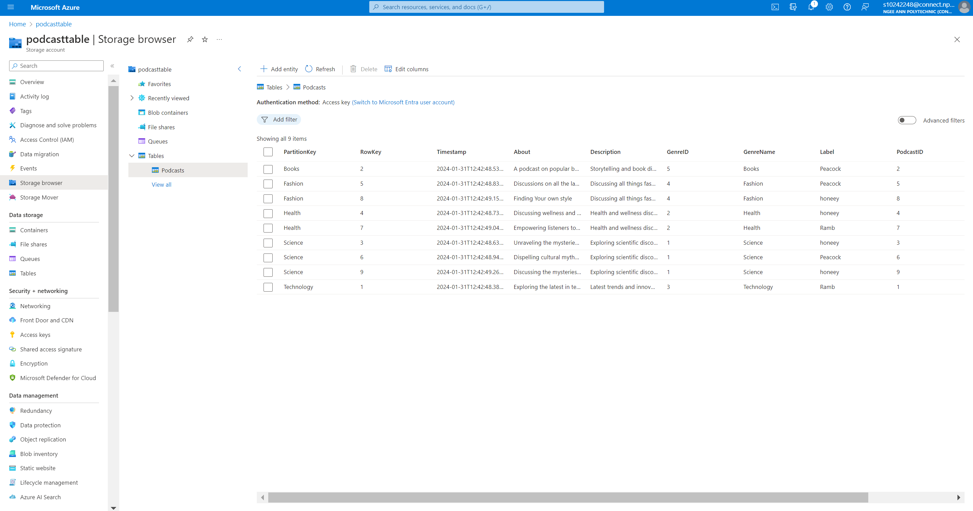

### PodcastEpisode Table

**Data Placement Strategies**

Row partitioning by podcast name in the Podcast Episode table introduces several strategic advantages that significantly enhance query performance and user experience, particularly when compared to scenarios with no partitioning or organization by podcast or date.

Reduced Data Scanning:

Row partitioning by podcast name narrows down the search scope, minimizing the data that needs to be scanned or filtered during queries. This is a substantial improvement compared to scenarios with no partitioning, where queries may involve scanning through all episodes, leading to increased processing time and resource consumption.

Hierarchical Organization:

Organizing data by podcast name aligns seamlessly with the hierarchical structure of podcast data. This logical arrangement simplifies queries related to specific podcasts, providing an intuitive organization that enhances overall processing efficiency.

Even Data Distribution:

Row partitioning by podcast name facilitates even distribution of data across different partitions based on podcast names. This strategic distribution helps avoid potential hotspots, ensuring a balanced load on the system and preventing performance bottlenecks that may occur in scenarios without partitioning.

Focused Retrieval for Users:

Compared to organizing data by date, row partitioning by podcast name allows for more focused retrieval of episodes related to a specific podcast. This enhances the overall user experience by providing an organized and streamlined approach to accessing episodes within users' favourite podcasts, aligning with their natural search patterns.

Intuitive Navigation:

The intuitive organizational structure resulting from partitioning by podcast name facilitates easier navigation and exploration of episodes within users' favourite podcasts. Users can seamlessly find and enjoy episodes without unnecessary complexity, contributing to a positive and user-friendly experience.

Efficient Episode Retrieval:

Row partitioning by podcast name reduces the complexity of queries related to episode retrieval compared to organizing by date. The streamlined process optimizes the efficiency of queries, providing a more straightforward and user-friendly experience that aligns with the evolving demands of podcast applications.

In summary, the adoption of row partitioning by podcast name tailors the data structure to the specific needs of podcast applications. This approach not only optimizes query performance but also enhances the overall user experience, surpassing alternatives with no partitioning or organization by podcast or date. It provides a streamlined and user-friendly solution that aligns seamlessly with the dynamic nature of podcast content.

Before Partitioning

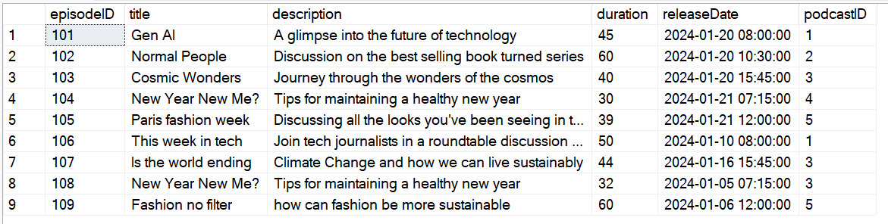

After Partitioning







**Cloud Storage Strategies**

To store podcast episodes within a cloud-based infrastructure, the strategic choice of Blob storage emerges as an ideal solution for the PodcastEpisode table. Services such as Amazon S3 or Azure Blob Storage, specifically designed for storing sizable binary objects like audio or video files, offer crucial features encompassing redundancy, scalability, and access control. This storage paradigm proves particularly advantageous for podcast hosting platforms, addressing the specific demands associated with large media files inherent in podcast episodes.

Key Factors Grounding the Decision to Use Blob Storage:

Handling Large Media Files:

Blob storage excels in handling large media files, aligning seamlessly with the nature of podcast content. This capability ensures an optimal storage solution for audio files, a pivotal aspect for podcast platforms where the quality and efficient delivery of media content directly impact user satisfaction.

Scalability for Dynamic Platforms:

The inherent scalability of Blob storage addresses the dynamic nature of podcast platforms, accommodating varying workloads and surges in user engagement. This scalability ensures high-throughput access to media content, a critical feature for platforms experiencing fluctuations in demand for podcast episodes.

Separation of Concerns:

The concept of separation of concerns is a compelling reason for leveraging Blob storage. Storing large media files in a dedicated service, distinct from databases optimized for transactional data, enhances modularity and ease of management. This separation contributes to scalability and efficiency, providing a streamlined storage solution for podcast episodes.

Strategic Implementation of Row Partitioning by Podcast Name:

Structured Organization:

Implementing row partitioning by podcast name within Blob storage refines the organizational structure, allowing for a structured arrangement of podcast episodes. This facilitates efficient retrieval and management based on podcast names, aligning with user expectations and offering streamlined access to episodes within specific podcasts.

Business Perspective and Enhanced User Experience:

Meeting User Expectations:

The strategic implementation of Blob storage, coupled with row partitioning by podcast name, aligns with user expectations. It offers streamlined access to episodes within specific podcasts, contributing to an enhanced user experience and satisfaction.

In summary, the adoption of Blob storage for the PodcastEpisode table proves to be a strategic choice for podcast platforms. It effectively addresses the unique storage needs of large media files, ensures scalability for varying workloads, introduces a separation of concerns for efficient management, and optimizes the organization and accessibility of podcast episodes. This strategic approach ultimately contributes to an enriched user experience within podcast platforms.

**Design**

Components of the podcast Blob

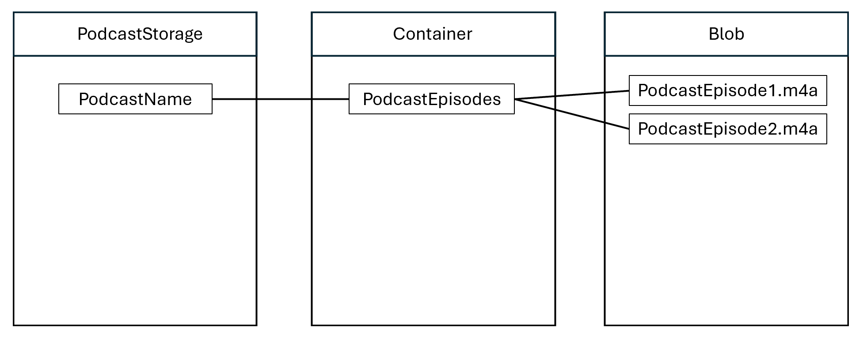

The provided C# code is a sample application showcasing the use of Azure Blob Storage. It demonstrates how to interact with Azure Blob Storage using the Azure.Storage.Blobs.Models namespace. The primary goal of this application is to upload a local file to Azure Blob Storage.

using Azure.Storage.Blobs.Models;

using System;

using System.IO;

using Azure.Identity;

using Azure.Storage.Blobs;

// TODO: Replace <Connection-string> with the actual Connection string of your storage account.

string connectionString = "DefaultEndpointsProtocol=https;AccountName=podcastepisode;AccountKey=ksOsde6C8+RN+25pwBlhOoZv26/QkXgDIXVxOrtP9M6MucgSO4qZEieIz7Sq6N3sG6rPvlj6wR7d+AStei/4MQ==;EndpointSuffix=core.windows.net";

//Create a blobServiceClient for the above Connection string

BlobServiceClient blobServiceClient = new

BlobServiceClient(connectionString);

//Create a unique name for the container. Use your students ID.

string containerName = "podcastepisodeblobcontainer";

//Get a BlobContainerClient

var container = blobServiceClient.GetBlobContainerClient(containerName);

//create a BlobContainerClient variable.

BlobContainerClient containerClient;

//Check if the container exists or not. If not, then create it.

bool isExist = container.Exists();

if (!isExist)

{

Console.WriteLine("Creating the Container. Wait...");

// Create the container and return a container client object.

containerClient = await

blobServiceClient.CreateBlobContainerAsync(containerName);

Console.WriteLine("Container created...");

}

else

{

Console.WriteLine("Container already exists.");

//create a BlobContainerClient for the existing Container.

containerClient = new BlobContainerClient(connectionString,

containerName);

}

// Copy a local file (e.g.: "Xtra.png") in the "D:\ADB\" directory for uploading and downloading

string fileName = "podcastepisode.m4a";

string filePath = "C:\\/Users\\amelia\\zSchool\\Year 2\\Semester 2\\Advanced Databases\\Assignment 2\\";

string fullPath = filePath + fileName;

// Get a reference to a blob

BlobClient blobClient = containerClient.GetBlobClient(fileName);

// (1) Upload data from the local file

using (var fileStream = System.IO.File.OpenRead(fullPath))

{

Console.WriteLine("Uploading to Blob storage as blob:\n\t {0}\n", blobClient.Uri);

await blobClient.UploadAsync(fileStream, true);

}





### Podcast Log Table

**Data Placement Strategy**

Row partitioning by podcast name in the Podcast Episode table introduces several strategic advantages that significantly enhance query performance and user experience, particularly when compared to scenarios with no partitioning or organization by podcast or date.

Reduced Data Scanning:

Row partitioning by podcast name narrows down the search scope, minimizing the data that needs to be scanned or filtered during queries. This is a substantial improvement compared to scenarios with no partitioning, where queries may involve scanning through all episodes, leading to increased processing time and resource consumption.

Hierarchical Organization:

Organizing data by podcast name aligns seamlessly with the hierarchical structure of podcast data. This logical arrangement simplifies queries related to specific podcasts, providing an intuitive organization that enhances overall processing efficiency.

Even Data Distribution:

Row partitioning by podcast name facilitates even distribution of data across different partitions based on podcast names. This strategic distribution helps avoid potential hotspots, ensuring a balanced load on the system and preventing performance bottlenecks that may occur in scenarios without partitioning.

Focused Retrieval for Users:

Compared to organizing data by date, row partitioning by podcast name allows for more focused retrieval of episodes related to a specific podcast. This enhances the overall user experience by providing an organized and streamlined approach to accessing episodes within users' favourite podcasts, aligning with their natural search patterns.

Intuitive Navigation:

The intuitive organizational structure resulting from partitioning by podcast name facilitates easier navigation and exploration of episodes within users' favourite podcasts. Users can seamlessly find and enjoy episodes without unnecessary complexity, contributing to a positive and user-friendly experience.

Efficient Episode Retrieval:

Row partitioning by podcast name reduces the complexity of queries related to episode retrieval compared to organizing by date. The streamlined process optimizes the efficiency of queries, providing a more straightforward and user-friendly experience that aligns with the evolving demands of podcast applications.

In summary, the adoption of row partitioning by podcast name tailors the data structure to the specific needs of podcast applications. This approach not only optimizes query performance but also enhances the overall user experience, surpassing alternatives with no partitioning or organization by podcast or date. It provides a streamlined and user-friendly solution that aligns seamlessly with the dynamic nature of podcast content.

Before Partitioning

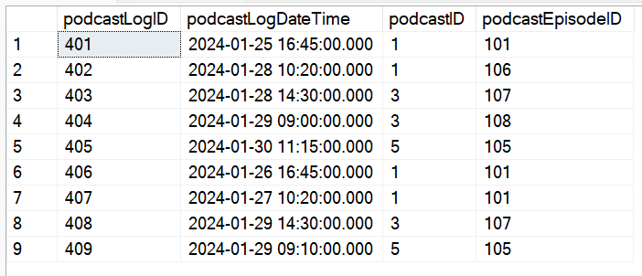

After Partitioning

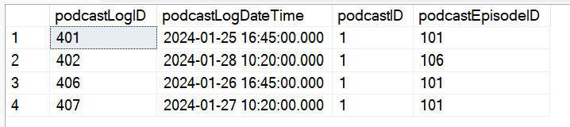

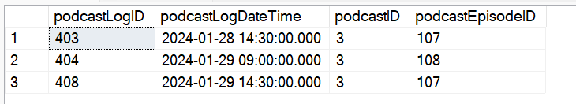

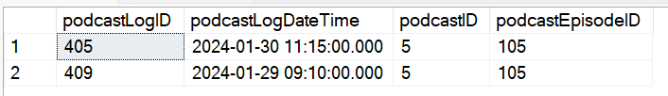

**Cloud Storage Strategies**

To manage podcast logs within a distributed database environment, Apache Cassandra columnar storage stands out as the optimal choice for the Podcast Log table. Cassandra, a robust NoSQL database, is renowned for its exceptional capabilities in high availability, scalability, and performance, making it particularly well-suited for distributed data models across multiple nodes and data centers.

Key Considerations:

Write-Heavy Workloads:

Cassandra's remarkable write throughput capabilities make it an ideal fit for scenarios characterized by write-heavy workloads. The frequent updates involved in recording podcast log events align seamlessly with Cassandra's strengths in managing write-intensive operations.

Horizontal Scaling and High Availability:

The distributed architecture of Cassandra enables horizontal scaling and high availability, perfectly addressing the demands of scenarios with high write activity, such as recording podcast log events. The ability to distribute data across multiple nodes ensures that the system can efficiently handle the influx of log requests while maintaining consistent performance.

Tuneable Consistency:

Cassandra's support for tuneable consistency is a significant advantage in a distributed environment. This feature ensures data consistency and availability by allowing users to configure the level of consistency required for each operation. Cassandra accommodates varying needs and performance trade-offs flexibly.

Storage Strategy Refinement:

Structured Organization:

Implementing row partitioning by PodcastID within Cassandra refines the storage strategy, allowing for a structured organization of podcast log records based on podcast identity. This caters to access patterns related to specific podcasts, enhancing the efficiency of queries related to podcast-specific logs.

Podcast-Centric Approach:

The podcast-centric approach is particularly beneficial for platforms where users seek detailed insights into the performance and interactions associated with specific podcasts. This strategy enables straightforward tracking of log events related to each podcast, contributing to a streamlined and podcast-centric analytical experience.

In summary, choosing Cassandra for the Podcast Log table proves to be a strategic decision that effectively addresses the specific challenges associated with managing podcast log records. Leveraging Cassandra's strengths in handling write-heavy workloads, supporting distributed architectures, and providing tuneable consistency, coupled with row partitioning by PodcastID, enhances podcast-centric access patterns. This, in turn, contributes to a more efficient and tailored podcast log management process, making Cassandra an ideal choice for platforms prioritizing reliability and performance in log data management.

**Design/Schema**

This C# code is a sample application demonstrating the use of Cassandra, a NoSQL database, in the context of cloud storage strategies. It specifically utilizes Cassandra's DataStax driver to interact with a Cassandra database.

using Cassandra;

using Cassandra.Mapping;

using System;

using System.Net.Security;

using System.Security.Authentication;

using System.Security.Cryptography.X509Certificates;

namespace ColumnarProject

{

public class PodcastLog

{

public short PodcastLogID { get; set; }

public DateTime PodcastLogDateTime { get; set; }

public short PodcastID { get; set; }

public short PodcastEpisodeID { get; set; }

public override string ToString()

{

return $"PodcastLogID: {PodcastLogID}, PodcastLogDateTime: {PodcastLogDateTime}, PodcastID: {PodcastID}, PodcastEpisodeID: {PodcastEpisodeID}";

}

}

public class Program

{

private const string CassandraContactPoint = "podcastlog.cassandra.cosmos.azure.com";

private const string UserName = "podcastlog";

private const string Password = "UXsD9ugILZgUjCvE7Ua7kzNSZpND5LMpz4ykalw531jRG2VGytB8QqMskoNUQIP8W1dyCQfHA9oHACDbI3AaOw==";

private static int CassandraPort = 10350;

public static void Main(string[] args)

{

var options = new Cassandra.SSLOptions(SslProtocols.Tls12, true, ValidateServerCertificate);

options.SetHostNameResolver((ipAddress) => CassandraContactPoint);

Cluster cluster = Cluster.Builder().WithCredentials(UserName, Password).WithPort(CassandraPort).AddContactPoint(CassandraContactPoint).WithSSL(options).Build();

ISession session = cluster.Connect();

// Creating a new Keyspace called "podcastlog"

session.Execute("DROP KEYSPACE IF EXISTS podcastlog");

session.Execute("CREATE KEYSPACE podcastlog WITH REPLICATION = { 'class' : 'NetworkTopologyStrategy', 'datacenter1' : 1 };");

Console.WriteLine(String.Format("Created keyspace podcastlog."));

// Creating a new table called "podcastlog"

session.Execute("CREATE TABLE IF NOT EXISTS podcastlog.podcastlog " +

"(podcastLogID smallint PRIMARY KEY, " +

"podcastLogDateTime timestamp, " +

"podcastID smallint, " +

"podcastEpisodeID smallint);");

Console.WriteLine(String.Format("Created table PodcastLog."));

// Creating indexes for foreign keys

session.Execute("CREATE INDEX IF NOT EXISTS idx_podcast_episode ON podcastlog.podcastlog (podcastEpisodeID);");

session.Execute("CREATE INDEX IF NOT EXISTS idx_podcast ON podcastlog.podcastlog (podcastID);");

session = cluster.Connect("podcastlog");

IMapper mapper = new Mapper(session);

IMapper podcastLogMapper = new Mapper(session);

// Inserting data into PodcastLog table

podcastLogMapper.InsertIfNotExists<PodcastLog>(new PodcastLog

{

PodcastLogID = 401,

PodcastLogDateTime = new DateTime(2024, 01, 25, 16, 45, 0),

PodcastID = 1,

PodcastEpisodeID = 101

});

podcastLogMapper.InsertIfNotExists<PodcastLog>(new PodcastLog

{

PodcastLogID = 402,

PodcastLogDateTime = new DateTime(2024, 01, 28, 10, 20, 0),

PodcastID = 1,

PodcastEpisodeID = 106

});

podcastLogMapper.InsertIfNotExists<PodcastLog>(new PodcastLog

{

PodcastLogID = 403,

PodcastLogDateTime = new DateTime(2024, 01, 28, 14, 30, 0),

PodcastID = 3,

PodcastEpisodeID = 107

});

podcastLogMapper.InsertIfNotExists<PodcastLog>(new PodcastLog

{

PodcastLogID = 404,

PodcastLogDateTime = new DateTime(2024, 01, 29, 09, 0, 0),

PodcastID = 3,

PodcastEpisodeID = 108

});

podcastLogMapper.InsertIfNotExists<PodcastLog>(new PodcastLog

{

PodcastLogID = 405,

PodcastLogDateTime = new DateTime(2024, 01, 30, 11, 15, 0),

PodcastID = 5,

PodcastEpisodeID = 105

});

podcastLogMapper.InsertIfNotExists<PodcastLog>(new PodcastLog

{

PodcastLogID = 406,

PodcastLogDateTime = new DateTime(2024, 01, 26, 16, 45, 0),

PodcastID = 1,

PodcastEpisodeID = 101

});

podcastLogMapper.InsertIfNotExists<PodcastLog>(new PodcastLog

{

PodcastLogID = 407,

PodcastLogDateTime = new DateTime(2024, 01, 27, 10, 20, 0),

PodcastID = 1,

PodcastEpisodeID = 101

});

podcastLogMapper.InsertIfNotExists<PodcastLog>(new PodcastLog

{

PodcastLogID = 408,

PodcastLogDateTime = new DateTime(2024, 01, 29, 14, 30, 0),

PodcastID = 3,

PodcastEpisodeID = 107

});

podcastLogMapper.InsertIfNotExists<PodcastLog>(new PodcastLog

{

PodcastLogID = 409,

PodcastLogDateTime = new DateTime(2024, 01, 29, 09, 10, 0),

PodcastID = 5,

PodcastEpisodeID = 105

});

Console.WriteLine("Inserted data into PodcastLog table.");

// Querying to get all PodcastLog information

Console.WriteLine("\nSelect ALL from PodcastLog");

Console.WriteLine("-------------------------------");

foreach (PodcastLog podcastLog in podcastLogMapper.Fetch<PodcastLog>("Select * from podcastlog.podcastlog"))

{

Console.WriteLine(podcastLog);

}

// Clean up of Table and KeySpace

// session.Execute("DROP table podcastlog");

// session.Execute("DROP KEYSPACE podcastlog");

Console.WriteLine("-------------------------------");

Console.WriteLine("\nPress Enter key to exit.");

Console.ReadLine();

}

public static bool ValidateServerCertificate(

object sender,

X509Certificate certificate,

X509Chain chain,

SslPolicyErrors sslPolicyErrors)

{

if (sslPolicyErrors == SslPolicyErrors.None)

return true;

Console.WriteLine("Certificate error: {0}", sslPolicyErrors);

// Do not allow this client to communicate with unauthenticated servers.

return false;

}

}

}

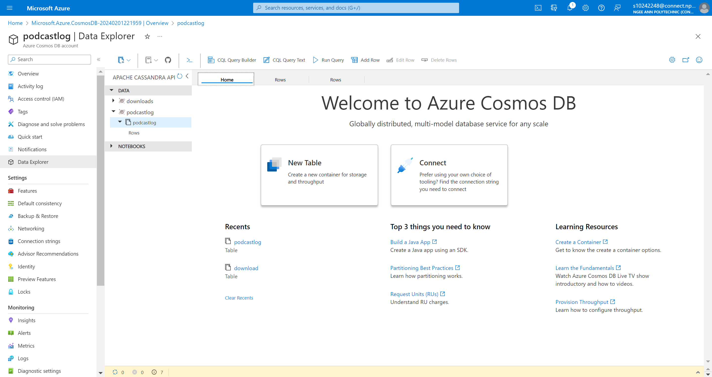



### Download Table

**Data Placement Strategies**

In structuring the Download table, the adoption of row partitioning by UserID emerges as a highly effective data placement strategy. Tailored to the table's primary purpose of managing download records, this approach offers distinct advantages by evenly distributing data across nodes and optimizing query performance based on user-centric access to downloaded content.

Key Benefits:

User-Centric Queries:

Row partitioning by UserID is especially beneficial for scenarios where queries involve retrieving all downloads associated with a specific user. This user-centric approach aligns seamlessly with the primary use case of users managing and accessing their individual download history.

Minimized Data Scanning:

The strategic organization of data in partitions based on UserID minimizes the amount of data that needs to be scanned or filtered during user-specific queries. This results in a more efficient and tailored experience for users seeking to view or manage their downloads.

Preventing Bottlenecks:

Distributing downloads across partitions based on UserID supports scalability by preventing bottlenecks and enabling horizontal scaling. This partitioning strategy ensures that, as the user base and associated downloads grow, the system can scale seamlessly without compromising performance.

Avoiding Concentration Issues:

Each user's downloads are distributed across multiple partitions, preventing concentration and potential performance issues. This design choice contributes to a robust and scalable system capable of handling increased user engagement over time.

Subscriber-Centric Tracking:

Partitioning by UserID, rather than song or episode ID, is a strategic decision aligned with the specific nature of the Download table designed initially for subscribers. This choice simplifies the tracking of which subscriber downloaded what content, facilitating efficient monitoring and management of subscriber-specific download activities.

Clear Organization of Download Records:

The approach ensures a clear and straightforward organization of download records, catering to the specific needs of subscribers. It streamlines the download management process, providing an organized and user-friendly experience for subscribers.

In summary, row partitioning by UserID in the Download table is a judicious choice for applications prioritizing efficient download access based on user identity. This data placement strategy optimizes query performance, enhances scalability, and aligns seamlessly with the user-centric nature of the Download table, contributing to an overall improved user experience.

Before Partitioning

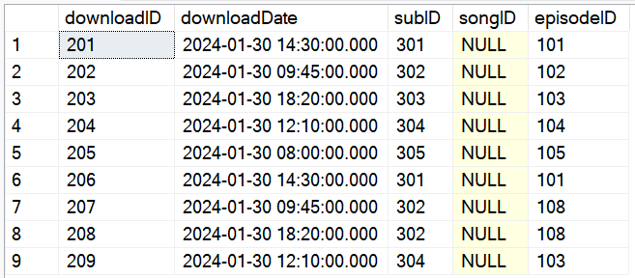

After Partitioning

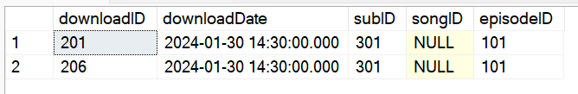

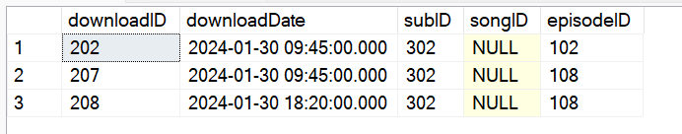

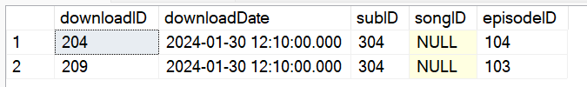

**Cloud Storage Strategies**

When managing download records within a distributed database environment, Apache Cassandra columnar storage stands out as the optimal choice for the Download table. Cassandra, a robust NoSQL database, is renowned for its exceptional capabilities in high availability, scalability, and performance, making it particularly well-suited for distributed data models across multiple nodes and data centers.

Key Considerations:

Exceptional Write Throughput:

Cassandra's remarkable write throughput capabilities make it an ideal fit for scenarios characterized by write-heavy workloads, a common trait in storing download data. The frequent updates involved in recording download events align seamlessly with Cassandra's strengths in managing write-intensive operations.

Horizontal Scaling and High Availability:

The distributed architecture of Cassandra enables horizontal scaling and high availability, perfectly addressing the demands of scenarios with high write activity, such as recording download events. The ability to distribute data across multiple nodes ensures that the system can efficiently handle the influx of download requests while maintaining consistent performance.

Flexible Consistency Levels:

Cassandra's support for tuneable consistency is a significant advantage in a distributed environment. This feature ensures data consistency and availability by allowing users to configure the level of consistency required for each operation. Cassandra accommodates varying needs and performance trade-offs flexibly.

Storage Strategy Refinement:

Structured Organization:

Implementing row partitioning by UserID within Cassandra refines the storage strategy, allowing for a structured organization of download records based on user identity. This caters to user-centric access patterns, enhancing the efficiency of queries related to user-specific downloads.

User-Centric Approach:

The user-centric approach is particularly beneficial for platforms where subscribers have exclusive access to the download feature. This strategy enables straightforward tracking of which subscriber downloaded what content, contributing to a streamlined and personalized experience.

In summary, choosing Cassandra for the Download table proves to be a strategic decision that effectively addresses the specific challenges associated with managing download records. Leveraging Cassandra's strengths in handling write-heavy workloads, supporting distributed architectures, and providing tuneable consistency, coupled with row partitioning by UserID, enhances user-centric access patterns. This, in turn, contributes to a more efficient and tailored download management process, making Cassandra an ideal choice for platforms prioritizing reliability and performance in download data management.

**Design/Schema**

The provided C# code demonstrates how to interact with Cassandra using the DataStax driver in a C# application. It includes setting up a connection to Cassandra, creating a keyspace and table, inserting data, querying the data, and handling SSL/TLS certificate validation.

using Cassandra;

using Cassandra.Mapping;

using System;

using System.Net.Security;

using System.Security.Authentication;

using System.Security.Cryptography.X509Certificates;

namespace ColumnarProject

{

public class Download

{

public int DownloadID { get; set; }

public DateTime DownloadDate { get; set; }

public int SubID { get; set; }

public int? SongID { get; set; }

public int? EpisodeID { get; set; }

public override string ToString()

{

return $"DownloadID: {DownloadID}, DownloadDate: {DownloadDate}, SubID: {SubID}, SongID: {SongID}, EpisodeID: {EpisodeID}";

}

}

public class Program

{

// Cassandra Cluster Configs

private const string CassandraContactPoint = "download.cassandra.cosmos.azure.com";

private const string UserName = "download";

private const string Password = "Kfjrdj3Xj06GtSbk5lVnv4EmNMv35RBAjxQF2xFkV9uvlLxhTFrmKzZCFkfCyMy1URL8aPYcDJ0nACDbstmfvA==";

private static int CassandraPort = 10350;

public static void Main(string[] args)

{

// Connecting to Cassandra cluster

var options = new Cassandra.SSLOptions(SslProtocols.Tls12, true, ValidateServerCertificate);

options.SetHostNameResolver((ipAddress) => CassandraContactPoint);

Cluster cluster = Cluster.Builder().WithCredentials(UserName, Password).WithPort(CassandraPort).AddContactPoint(CassandraContactPoint).WithSSL(options).Build();

ISession session = cluster.Connect();

// Creating a new KeySpace called "downloads"

session.Execute("DROP KEYSPACE IF EXISTS downloads");

session.Execute("CREATE KEYSPACE downloads WITH REPLICATION = { 'class' : 'NetworkTopologyStrategy', 'datacenter1' : 1 };");

Console.WriteLine(String.Format("Created keyspace downloads."));

// Creating a new table called "download"

session.Execute("CREATE TABLE IF NOT EXISTS downloads.download (downloadID int PRIMARY KEY, downloadDate timestamp, subID int, songID int, episodeID int);");

Console.WriteLine(String.Format("Created table download."));

session = cluster.Connect("downloads");

IMapper mapper = new Mapper(session);

// Inserting new download entities by using the IMapper object with a new session that connects to the downloads keyspace

// Inserting new download entities using the IMapper object with a new session that connects to the downloads keyspace

mapper.InsertIfNotExists<Download>(new Download

{

DownloadID = 201,

DownloadDate = new DateTime(2024, 01, 30, 14, 30, 0),

SubID = 301,

SongID = null,

EpisodeID = 101

});

mapper.InsertIfNotExists<Download>(new Download

{

DownloadID = 202,

DownloadDate = new DateTime(2024, 01, 30, 09, 45, 0),

SubID = 302,

SongID = null,

EpisodeID = 102

});

mapper.InsertIfNotExists<Download>(new Download

{

DownloadID = 203,

DownloadDate = new DateTime(2024, 01, 30, 18, 20, 0),

SubID = 303,

SongID = null,

EpisodeID = 103

});

mapper.InsertIfNotExists<Download>(new Download

{

DownloadID = 204,

DownloadDate = new DateTime(2024, 01, 30, 12, 10, 0),

SubID = 304,

SongID = null,

EpisodeID = 104

});

mapper.InsertIfNotExists<Download>(new Download

{

DownloadID = 205,

DownloadDate = new DateTime(2024, 01, 30, 08, 00, 0),

SubID = 305,

SongID = null,

EpisodeID = 105

});

mapper.InsertIfNotExists<Download>(new Download

{

DownloadID = 206,

DownloadDate = new DateTime(2024, 01, 30, 14, 30, 0),

SubID = 301,

SongID = null,

EpisodeID = 101

});

mapper.InsertIfNotExists<Download>(new Download

{

DownloadID = 207,

DownloadDate = new DateTime(2024, 01, 30, 09, 45, 0),

SubID = 302,

SongID = null,

EpisodeID = 108

});

mapper.InsertIfNotExists<Download>(new Download

{

DownloadID = 208,

DownloadDate = new DateTime(2024, 01, 30, 18, 20, 0),

SubID = 302,

SongID = null,

EpisodeID = 108

});

mapper.InsertIfNotExists<Download>(new Download

{

DownloadID = 209,

DownloadDate = new DateTime(2024, 01, 30, 12, 10, 0),

SubID = 304,

SongID = null,

EpisodeID = 103

});

Console.WriteLine("Inserted data into download table.");

// Querying to get all download information

Console.WriteLine("\nSelect ALL");

Console.WriteLine("-------------------------------");

foreach (Download download in mapper.Fetch<Download>("Select * from download"))

{

Console.WriteLine(download);

}

// Clean up of Table and KeySpace

// session.Execute("DROP table download");

// session.Execute("DROP KEYSPACE downloads");

Console.WriteLine("-------------------------------");

Console.WriteLine("\nPress Enter key to exit.");

Console.ReadLine();

}

public static bool ValidateServerCertificate(

object sender,

X509Certificate certificate,

X509Chain chain,

SslPolicyErrors sslPolicyErrors)

{

if (sslPolicyErrors == SslPolicyErrors.None)

return true;

Console.WriteLine("Certificate error: {0}", sslPolicyErrors);

// Do not allow this client to communicate with unauthenticated servers.

return false;

}

}

}

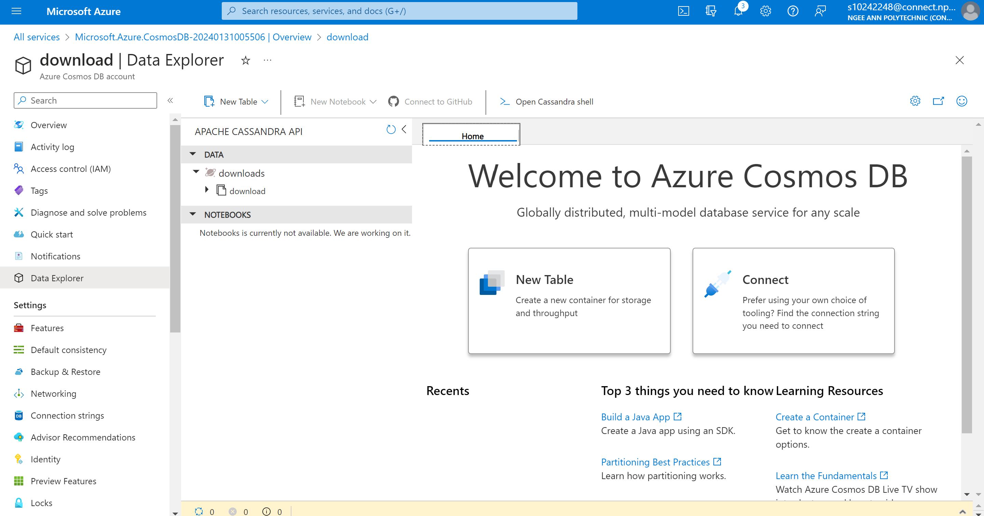



### Review Table

**Data Placement Strategies**

In designing the structure of the Review table, the strategic implementation of row partitioning by rating emerges as a well-advised data placement strategy. This approach is particularly fitting considering the substantial data volume within the table and the frequent user requirement for accessing reviews based on their ratings. The partitioning of the Review table based on rating ensures efficient access to reviews with specific ratings, fostering an even distribution of data across nodes or shards. This strategic approach plays a pivotal role in enhancing both the overall performance and scalability of the application, addressing user-centric requirements and minimizing contention and locking issues within the data.

Key Considerations:

Streamlined Retrieval:

Row partitioning by rating streamlines the retrieval of reviews based on specific ratings, resulting in enhanced query performance. This aligns seamlessly with user preferences, enabling faster access to reviews that match their desired rating criteria.

Optimal Performance During Peaks:

The benefits of row partitioning extend to scalability, ensuring optimal performance even during periods of increased user activity. By distributing the computational load across multiple partitions, this strategy accommodates varying workloads and user engagement levels.

Simplified Data Aggregation:

Row partitioning facilitates efficient aggregation operations, particularly when aggregating reviews by rating is a common task. The grouping of reviews by rating within partitions simplifies these operations, contributing to efficient data retrieval.

Responsive to User Needs:

The deliberate choice of partitioning by rating, rather than user, is strategic due to its alignment with users' primary focus on review ratings when accessing and evaluating feedback. This strategic alignment enhances the speed and efficiency of accessing reviews based on specific rating criteria.

Contention and Locking Mitigation:

This approach minimizes potential contention and locking issues that might arise in scenarios without partitioning or with alternative partitioning strategies. The strategic choice of row partitioning by rating optimizes the performance, scalability, and user experience of the Review table.

In summary, row partitioning by rating proves to be a judicious choice for optimizing the performance, scalability, and user experience of the Review table. This strategic approach aligns with user-centric needs, ensuring efficient access to reviews based on rating criteria while mitigating potential contention and locking issues. Applications prioritizing efficient review access based on rating will benefit significantly from this well-thought-out data placement strategy.

**Cloud Storage Strategies**

In the realm of download record management within a distributed database environment, the strategic decision to employ Azure Queue Storage, coupled with row partitioning by rating in the Download table, offers a robust solution that marries technical prowess with business considerations. Azure Queue Storage, a scalable and highly available messaging service, seamlessly integrates with Azure Cosmos DB's row partitioning strategy to enhance various aspects of the system.

Efficient Event Processing:

Azure Queue Storage facilitates efficient event processing by acting as a reliable and decoupled messaging layer. Events related to new downloads, rating changes, or other relevant interactions can be seamlessly queued for asynchronous processing. This decoupling ensures that the system can handle varying workloads efficiently, contributing to improved responsiveness and scalability.

Scalability and Fault Tolerance:

The combination of row partitioning and Azure Queue Storage enhances the system's scalability and fault tolerance. With Azure Queue Storage's ability to handle large volumes of messages, the system can scale horizontally to accommodate increasing download activities. In scenarios of temporary failures or spikes in traffic, the queue acts as a buffer, ensuring that download requests are queued and processed without loss, maintaining fault tolerance and data integrity.

Personalized Content Delivery:

Row partitioning by rating in the Download table aligns with user-centric objectives by enabling personalized content delivery. Azure Queue Storage supports the efficient retrieval of queued events related to specific rating partitions, allowing the system to tailor content recommendations based on user preferences. This approach significantly contributes to an enhanced user experience, fostering user loyalty through personalized content suggestions.

Operational Streamlining:

Azure Queue Storage, being a managed service, simplifies operational aspects by handling the intricacies of message queuing. This allows the development team to focus on refining the download management system within Azure Cosmos DB, ensuring a robust and reliable platform for users. The managed service advantage streamlines administrative efforts, contributing to a more focused and efficient development process.

In conclusion, the strategic integration of Azure Queue Storage with row partitioning by rating in the Download table optimally addresses technical and business considerations. This combined approach ensures efficient event processing, scalability, fault tolerance, personalized content delivery, and operational streamlining, making it a sound choice for applications prioritizing effective download management within a distributed database environment.

**Design/Schema**

Components of the Review queue storage

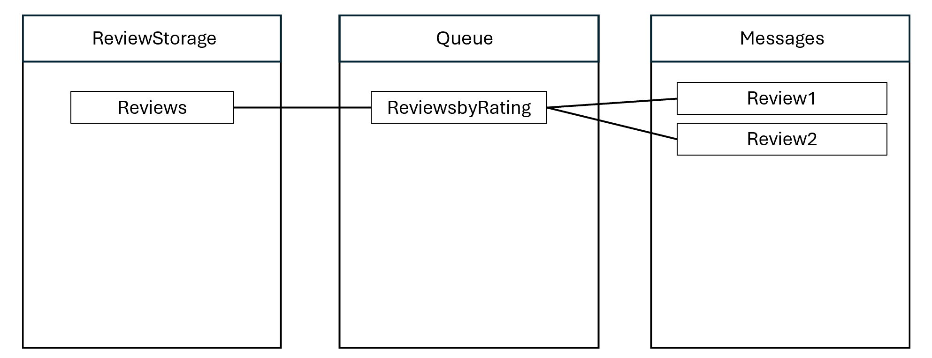

The provided C# code demonstrates how to interact with Azure Storage Queues using the Azure SDK for .NET. It includes creating a queue, adding messages to the queue, and peeking at messages in the queue.

using Azure;

using Azure.Storage.Queues;

using Azure.Storage.Queues.Models;

using System;

using System.Threading.Tasks;

// TODO: Replace <Connection-string> with the actual Connection string of your storage account.

string connectionString = "DefaultEndpointsProtocol=https;AccountName=reviewqueuestorage;AccountKey=VCVueqtF/Efn9CtZ8oYIBlHLw1/j0vuaD/HO5gMQkuU8GXbNalrZL+NWqsv08DqAQlvR9xsyJboh+ASt0T6NoQ==;EndpointSuffix=core.windows.net";

//Create a unique name for the queue. Queue names must be lowercase.

string queueName = "reviewqueue";

// Instantiate a QueueClient to create and interact with the queue

QueueClient queueClient = new QueueClient(connectionString,

queueName);

// Create the queue

Console.WriteLine($"Creating queue: {queueName}");

await queueClient.CreateAsync();

// (2) Add messages to a queue

Console.WriteLine("\nAdding messages to the queue...");

// Send several messages to the queue

await queueClient.SendMessageAsync("Review 501");

await queueClient.SendMessageAsync("Review 502");

await queueClient.SendMessageAsync("Review 503");

// (3) Peek at messages in a queue

Console.WriteLine("\nPeek at the messages in the queue...");

// Peek at messages in the queue

PeekedMessage[] peekedMessages = await

queueClient.PeekMessagesAsync(maxMessages: 10);

foreach (PeekedMessage peekedMessage in peekedMessages)

{

// Display the message

Console.WriteLine($"Message: {peekedMessage.MessageText}");

}





### Business Queries (revised)

What are the top 3 podcast genres that have the most downloads?

SELECT genreName AS Genre, COUNT(DISTINCT downloadId) AS UniqueDownloads

FROM podcast p

INNER JOIN podcastEpisode e ON p.podcastId = e.podcastId

GROUP BY genreName

ORDER BY UniqueDownloads DESC

LIMIT 5;

What was the top 5 most listened to podcasts in the previous year?

SELECT p.podcastID, podcastName, COUNT(genreId) AS NoOfGenres, SUM(podcastLogID) AS totalNoListens

FROM podcast p

INNER JOIN podcastEpisode e ON p.podcastID = e.podcastID

INNER JOIN podcastLog l ON p.podcastID = l.podcastID

WHERE YEAR(releaseDate) = (YEAR(GETDATE()) - 1)

GROUP BY p.podcastId, podcastName

ORDER BY totalNoListens DESC

LIMIT 5;

## Yi Hui

## Jovin

### User table

1. **Denormalization**

**User table**

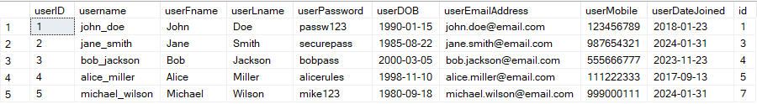

Figure 5 User table in MySQL

User (userID, username, userFname, userLname, userPassword, userDOB, userEmailAddress, userAddress userDateJoined, userMobile, <countryCode>)

**Country table**

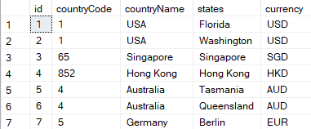

Figure 6 Country table in MySQL

Country (countryCode, countryName, currency)

**UserCountry table**

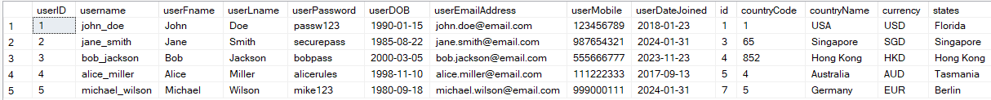



Figure 7 After denormalization, UserCountry table in MySQL

UserCountry (userID, username, userFname, userLname, userPassword, userDOB, userListenDuration, userDateJoined, userEmailAddress, userMobile, userAddress, userProfilePic, <countryCode>, countryName, currency)

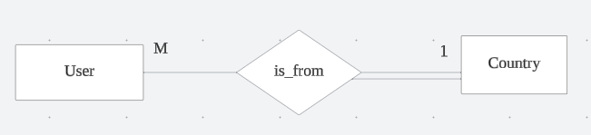

Figure 8 Relationship between the User and Country Tables

To acquire details regarding the country of residence for each user, it is imperative to execute join operations between the user and country tables. However, the repetitive application of multiple join queries may have a detrimental impact on the expeditious retrieval of data. In the business context, optimizing the efficiency of user information retrieval is crucial for Musify to expedite the payment processing workflow effectively.

The denormalization process involves merging the Country and User tables into a unified entity referred to as the UserCountry table. Given the prevalent Many-to-One relationship between the User and Country tables, the attributes from the Country table are appended to the User table. This denormalization technique entails duplicating non-key attributes within one-to-many relationships, streamlining data retrieval, and enhancing the efficiency of information access. In addition, the data of the Country do not need to be updated frequently, therefore denormalizing the User and Country table would be beneficial to the database system.

**Queries before denormalization:**

SELECT userID, username, userDOB, countryCode, states

FROM [User] u

INNER JOIN Country c ON u.id = c.id

WHERE c.countryName = 'Singapore'

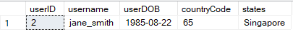

Figure 9 Result from the above query

**Queries after denormalization:**

SELECT userID, username, userDOB, countryCode, states

FROM userNormalised

WHERE countryName = 'Singapore'

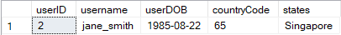

Figure 10 Result from the above query

1. **Data Placement Strategy**

As the Musify user base continues to expand, retrieving information for an individual user could become a cumbersome and time-consuming process. As a Database Engineer, it's crucial to ensure that user data can be accessed swiftly, especially considering Musify's global user demographic. The goal is to avoid any delays or access denials when users attempt to log into their Musify accounts for music services. This is particularly vital for Musify's premium subscribers who expect seamless and expedited authentication, having paid for an enhanced service experience. Consequently, a strategic decision has been made to implement data partitioning based on the geographical states of countries, with a specific focus on large nations such as the United States. This initiative considers the potential challenges posed by countries with substantial Musify user populations, aiming to mitigate the time spent on data queries.

Partition by **states**

* a simplified version of the user table will be used to demonstrate the partition by states

**Pre-partition by states**

|  |  |  |  |
| --- | --- | --- | --- |
| userID | userName | userCountry | userState |
| 1 | john_doe | USA | Washington |
| 2 | jane_smith | Singapore | Singapore |
| 3 | bob_jackson | USA | Florida |
| 4 | alice_miller | USA | Washington |
| 5 | michael_wilson | USA | Florida |

Figure 11 UserCountry table before pre-partitioning

**Partitioned by states**

|  |  |  |  |
| --- | --- | --- | --- |
| userID | userName | userCountry | userState |
| 1 | john_doe | USA | Washington |
| 4 | alice_miller | USA | Washington |

|  |  |  |  |
| --- | --- | --- | --- |
| userID | userName | userCountry | userState |
| 2 | jane_smith | Singapore | Singapore |

|  |  |  |  |
| --- | --- | --- | --- |
| userID | userName | userCountry | userState |
| 3 | bob_jackson | USA | Florida |
| 5 | michael_wilson | USA | Florida |

Figure 12 UserCountry table after partitioning

.

1. **Selection of Cloud Storage Strategies**

After careful evaluation of diverse database storage options, the decision has been made to store user data in a **Document** **Database**, specifically MongoDB. This choice is informed by the numerous advantages offered by MongoDB, aligning with the strategic considerations for effective and scalable data management.

The various advantages offered by Document Database with MongoDB are:

* **Storage Efficiency:** Document databases are known for their flexibility in handling diverse data types within a single document. This allows for efficient storage of user-related information without the need for complex normalization processes. This can result in reduced storage costs compared to traditional relational databases.
* **Indexing Support:** Document databases provide indexing support, allowing for fast and efficient querying of data. Indexes can be created on specific fields within the user document, enabling quick searches based on various criteria such as username, email, or user ID. This can enhance the speed of queries related to user data.
* **Document-level Security:** Document databases often provide mechanisms for securing data at the document level. Access controls and permissions can be applied to individual documents, ensuring that only authorized users or applications can access specific user information. This helps in maintaining data security and privacy, especially in scenarios where different parts of the user data need varying levels of protection.

1. **Design / Schema and Content of Cloud Storage**

The User Document Database should allow the user to update their personal information. To allow better organizing of the user data, an embedded Document is chosen. Allowing user to store only one address, modelling a one-to-one relationship helps with a more efficient retrieval process of the document. Creating an embedded Document with a one-to-one relationship would be beneficial for the billing process.

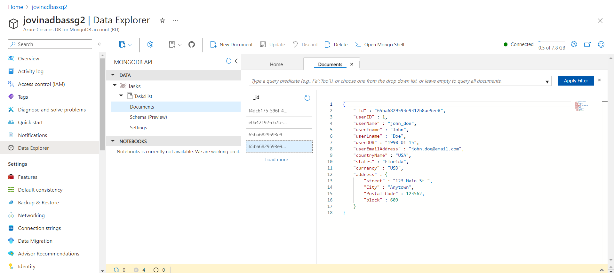

Figure 13 Azure Document Database attempt for UserCountry table

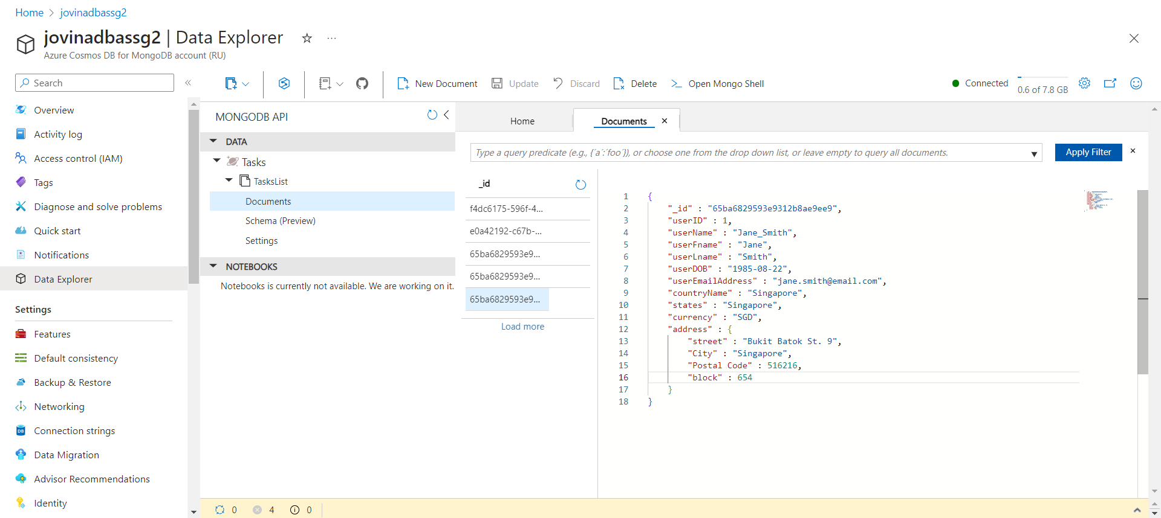

**Pre-partition**

{

"usertableid": "userID1",

"user": {

"userID": "1",

"username": "john_doe",

"userFname": "John",

"userLname": "Doe",

"userPassword": "passw123",

"userDOB": "1990-01-15",

"userEmailAddress": "john.doe@email.com",

"userMobile": "123456789",

"userDateJoined": "2018-01-23",

"id": 1,

"countryCode": 1,

"countryName": "United States",

"currency": "USD",

"states": "Florida",

"Address":

{

"Street": "123 Main ST.",

"City": "Anytown",

"Postal Code": 135468,

"block": 609,

"unit": "#10-179"

}

}

},

{

"usertableid": "userID2",

"user": {

"userID": "2",

"username": "jane_smith",

"userFname": "Jane",

"userLname": "Smith",

"userPassword": "securepass",

"userDOB": "1985-08-22",

"userEmailAddress": "jane.smith@email.com",

"userMobile": "987654321",

"userDateJoined": "2024-01-31",

"id": 3,

"countryCode": 65,

"countryName": "Singapore",

"currency": "SGD",

"states": "Singapore",

"Address":

{

"Street": "Bukit Batok St.62",

"City": "Singapore",

"Postal Code": 656130,

"block": 130,

"unit": "#15-165"

}

}

},

{

"usertableid": "userID3",

"user": {

"userID": "3",

"username": "bob_lee",

"userFname": "Bob",

"userLname": "Lee",

"userPassword": "strongpass",

"userDOB": "1992-05-08",

"userEmailAddress": "bob.lee@email.com",

"userMobile": "876543210",

"userDateJoined": "2023-02-14",

"id": 5,

"countryCode": 65,

"countryName": "Singapore",

"currency": "SGD",

"states": "Singapore",

"Address":

{

"Street": "Orchard Road",

"City": "Singapore",

"Postal Code": 238879,

"block": 55,

"unit": "#07-102"

}

}

}

**Partitioned by Country**

{

"partitionKey": "USA",

"usertableid": "userID1",

"user": {

"userID": "1",

"username": "john_doe",

"userFname": "John",

"userLname": "Doe",

"userPassword": "passw123",

"userDOB": "1990-01-15",

"userEmailAddress": "john.doe@email.com",

"userMobile": "123456789",

"userDateJoined": "2018-01-23",

"id": 1,

"countryCode": 1,

"countryName": "United States",

"currency": "USD",

"states": "Florida",

"Address":

{

"Street": "123 Main ST.",

"City": "Anytown",

"Postal Code": 135468,

"block": 609,

"unit": "#10-179"

}

}

},

{

"partitionKey": "Singapore",

"users":

[

"usertableid": "userID2",

"user": {

"userID": "2",

"username": "jane_smith",

"userFname": "Jane",

"userLname": "Smith",

"userPassword": "securepass",

"userDOB": "1985-08-22",

"userEmailAddress": "jane.smith@email.com",

"userMobile": "987654321",

"userDateJoined": "2024-01-31",

"id": 3,

"countryCode": 65,

"countryName": "Singapore",

"currency": "SGD",

"states": "Singapore",

"Address":

{

"Street": "Bukit Batok St.62",

"City": "Singapore",

"Postal Code": 656130,

"block": 130,

"unit": "#15-165"

}

}

},

{

"usertableid": "userID3",

"user": {

"userID": "3",

"username": "bob_lee",

"userFname": "Bob",

"userLname": "Lee",

"userPassword": "strongpass",

"userDOB": "1992-05-08",

"userEmailAddress": "bob.lee@email.com",

"userMobile": "876543210",

"userDateJoined": "2023-02-14",

"id": 5,

"countryCode": 65,

"countryName": "Singapore",

"currency": "SGD",

"states": "Singapore",

"Address":

{

"Street": "Orchard Road",

"City": "Singapore",

"Postal Code": 238879,

"block": 55,

"unit": "#07-102"

}

}

}

]

### Subscriber table

1. **Denormalization**

Denormalization of the SubscriptionPlan table into the Subscriber table

**Subscriber table**

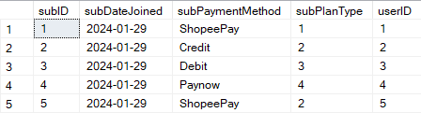

Figure 14 Subscriber table in MySQL

Subscriber (<subID>, subDateJoined, subPaymentMethod, <planID>)

**SubscriptionPlan table**

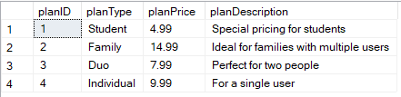

Figure 15 SubscriptionPlan table in MySQL

SubscriptionPlan (planID, planType, planPrice, planDescription)

**SubscriberNormalised table**

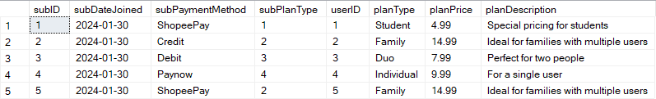



Figure 16 SubscriberNormalized table in MySQL

SubscriberNormalised (<subID>, subDateJoined, subPaymentMethod, <planID>, planType, planDescription, planPrice)

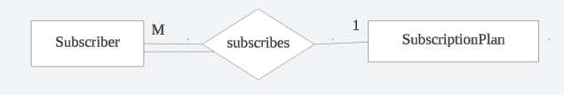

Figure 17 Relationship between the Subscriber and SubscriptionPlan tables

There are a lot of users using Musify, and the payment date for each user would highly depend on when they subscribed. This would suggest that Musify would be processing payments every day. It would be important for Musify to have a fast query of data, ensuring efficient workflow of the employee. There would not be a need to join the Subscriber table with the SubscriptionPlan table every time to obtain the data. Consideration of the frequency of data manipulation for the SubscriptionPlan Table indicates that updates, inserts, or deletes are infrequent. Given this low frequency of data manipulation, replicating the relevant SubscriptionPlan data into the Subscriber table emerges as a strategic approach. This replication can effectively diminish the necessity for frequent joins, thereby optimizing data retrieval and enhancing overall system performance.

**Queries before denormalization:**

SELECT subID, subDateJoined, planType, planPrice

FROM Subscriber s

INNER JOIN SubscriptionPlan sp

ON s.subPlanType = sp.planID

WHERE ROUND(planPrice, 1) >= 10;

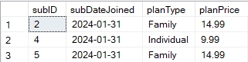

Figure 18 Results from the above query

**Queries after denormalization:**

SELECT subID, subDateJoined, planType, planPrice

FROM subscriberNormalized

WHERE ROUND(planPrice, 1) >= 10;

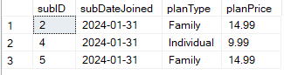

Figure 19 Results from the above query

1. **Data Placement Strategy**

To enhance the efficiency of data retrieval for Musify subscribers, a strategic decision has been made to implement data partitioning based on two key attributes: planType and subDateJoined. Partitioning the table by planType is anticipated to optimize data retrieval speed from the subscriber table, mitigating the need to scan every row and thereby reducing waiting times for Musify subscribers accessing premium features such as downloads and an ad-free experience.

* a simplified version of the Subscriber table will be shown for demonstration purposes

**Pre-partitioning**

|  |  |  |  |
| --- | --- | --- | --- |
| subID | subDateJoined | planType | planDescription |
| 1 | 2024-01-31 | Student | Special pricing for students |
| 2 | 2024-01-31 | Family | Ideal for families with multiple users |
| 3 | 2023-09-25 | Duo | Perfect for two people |
| 4 | 2023-09-20 | Individual | For a single user |
| 5 | 2023-09-20 | Individual | For a single user |
| 6 | 2023-09-12 | Family | Ideal for families with multiple users |
| 7 | 2023-08-12 | Individual | For a single user |

Figure 20 subscriptionNormalised before partitioning

**Partitioned by planType**

|  |  |  |  |
| --- | --- | --- | --- |
| subID | subDateJoined | planType | planDescription |
| 1 | 2024-01-31 | Student | Special pricing for students |

|  |  |  |  |
| --- | --- | --- | --- |
| subID | subDateJoined | planType | planDescription |
| 2 | 2024-01-31 | Family | Ideal for families with multiple users |
| 6 | 2023-09-25 | Family | Ideal for families with multiple users |

|  |  |  |  |
| --- | --- | --- | --- |
| subID | subDateJoined | planType | planDescription |
| 3 | 2023-09-25 | Duo | Perfect for two people |

|  |  |  |  |
| --- | --- | --- | --- |
| subID | subDateJoined | planType | planDescription |
| 4 | 2023-09-20 | Individual | For a single user |
| 5 | 2023-09-20 | Individual | For a single user |
| 7 | 2023-08-12 | Individual | For a single user |

Figure 21 subscriptionNormalised table after partitioning

1. **Selection of Cloud Storage Strategies**

After careful deliberation, the decision has been made to store the SubscriberNormalised table as a document database. This choice is particularly advantageous for handling potentially large datasets, as document databases offer scalability. Since subscribers have paid for premium services on Musify, it is imperative that the quality of service they receive surpasses standard offerings.

Several reasons for choosing Document Database:

1. **Horizontal scalability**: Document databases are structured for horizontal scalability, facilitating the distribution of data across numerous servers or nodes. This inherent capability simplifies the management of extensive datasets and the accommodation of escalating workloads through the seamless addition of servers to the database cluster. This horizontal scalability is pivotal in addressing the anticipated expansion of the SubscriberNormalised table.
2. **Fast Retrieval of data:** Retrieving data from a document database is typically fast, especially when the data is denormalized and closely aligned with the application's needs. Document databases allow embedding of data reducing the need for complex joins and improving read performance.
3. **Design / Schema and Content of Cloud Storage**



Figure 22 Azure Document Database attempt for subscriberNormalised table

Depending on how the partition is like for SubscriberNormalised table, the way the data stored within the document differs.

The application would need to obtain information, such as subID, from the SubscriberNormalised to see if the user is a subscriber. This process will need to be fast such that the subscriber can use the premium features upon logging in. Each subscriber is only entitled to one subscription plan, which suggest its relationship (one-to-one relationship). Therefore, it has been decided to store this table as a simple Document Database. It helps with the speed of retrieval of data, which is beneficial to the application.

**Pre-partition**

{

    {

        "subNorID" : "SN1",

        "subID": 1,

        "subDateJoined": "2024-01-31",

        "subPaymentMethod": "ShopeePay",

        "subPlanType": "Student",

        "planPrice": 4.99,

        "planDescription": "Special pricing for students"

    },

    {

        "subNorID" : "SN2",

        "subID": 2 ,

        "subDateJoined": "2024-01-31",

        "subPaymentMethod": "Paynow",

        "subPlanType": "Duo",

        "planPrice": 14.99,

        "planDescription": "Perfect for two people"

},

    {

        "subNorID" : "SN3",

        "subID": 3 ,

        "subDateJoined": "2024-01-31",

        "subPaymentMethod": "Credit",

        "subPlanType": "Student",

        "planPrice": 4.99,

        "planDescription": " Special pricing for students"

},

}

{

{

"partitionKey" : "Student",

"sub": [

        "subNorID" : "SN1",

        "subID": 1,

        "subDateJoined": "2024-01-31",

        "subPaymentMethod": "ShopeePay",

        "subPlanType": "Student",

        "planPrice": 4.99,

        "planDescription": "Special pricing for students"

    },

{

        "subNorID" : "SN3",

        "subID": 3 ,

        "subDateJoined": "2024-01-31",

        "subPaymentMethod": "Credit",

        "subPlanType": "Student",

        "planPrice": 4.99,

        "planDescription": " Special pricing for students"

}]

}

{

"partitionKey" : "Student",

"sub”: [

        "subNorID" : "SN2",

        "subID": 2 ,

        "subDateJoined": "2024-01-31",

        "subPaymentMethod": "Paynow",

        "subPlanType": "Duo",

        "planPrice": 14.99,

        "planDescription": "Perfect for two people"

]

}

}

### SubscriptionPlan table

1. **Denormalization**

As explained in the earlier part of the report, the Subscription table has been denormalized with the Subscriber table to form the subscriberNormalised table.

1. **Selection of Cloud Storage Strategies**

As a data engineer, SubscriptionPlan table has been decided to be stored as a Key-Value Store within Azure Table Storage. SubsciptionPlan stores the values such as plan type, plan price, plan description and the primary key to uniquely identify each subscription plan. To query for one subscription plan would not require a powerful query capability as there is only 4 rows within this table.

Several reasons for choosing Key-Value Store:

* 1. **Cost-effective**: Azure Table Storage offers a cost-effective solution, especially in scenarios involving small datasets. The pricing model is structured to align with the storage consumed, and it tends to be more advantageous for situations with a relatively limited number of rows when compared to alternative storage solutions.
  2. **Global Distribution**: In the event of a worldwide distribution, Azure Table Storage facilitates data replication across multiple regions, guaranteeing users across the globe low-latency access.
  3. **High Availability:** Azure Table Storage automatically replicates your data to ensure high availability and fault tolerance. This means that even in the case of hardware failures or other issues, your data remains accessible.

1. **Design / Schema and Content of Cloud Storage**

The initial key property of the table is designated as the PartitionKey and is assigned the primary key value to uniquely identify each row. Subsequently, the RowKey is employed as the distinctive identifier for an entity within a partition, with the plan type of the subscription plans serving as the designated row key.



Figure 23 Azure table storage attempted for SubscriptionPlan table

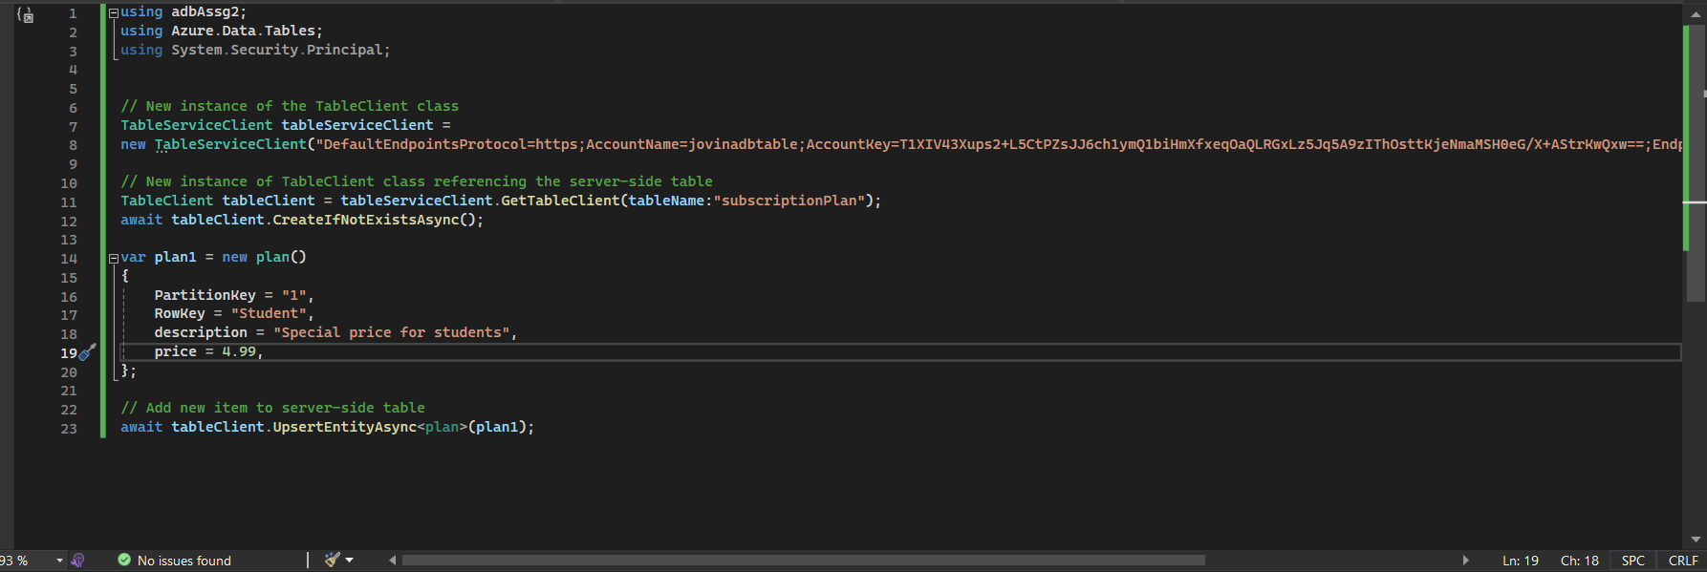

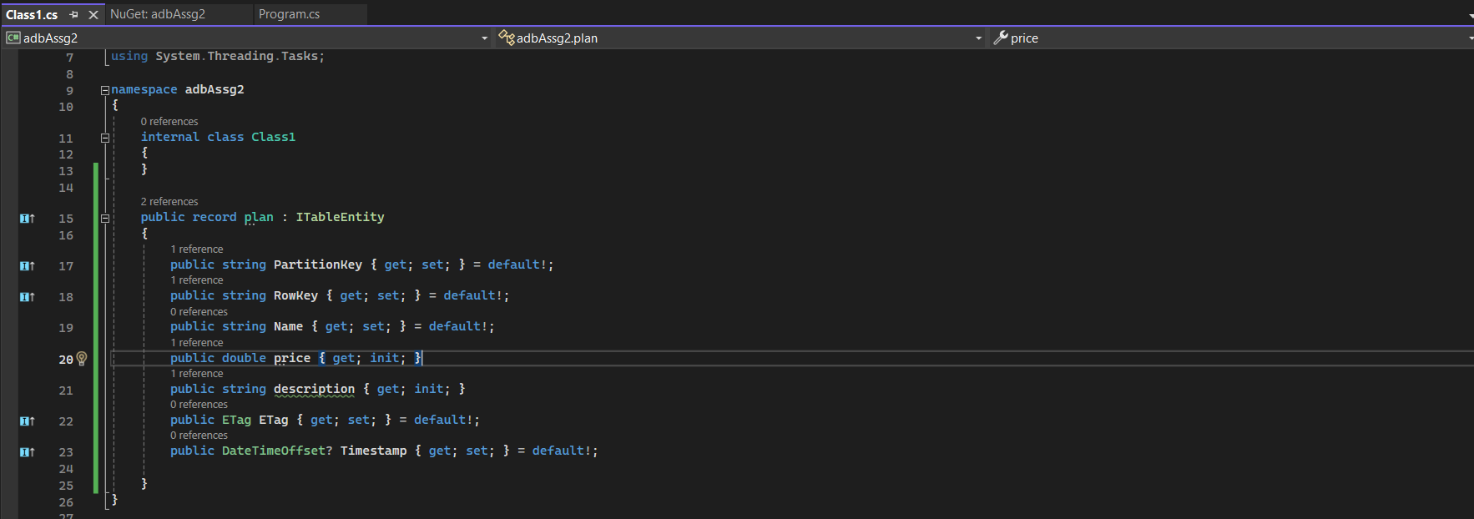

### TransLog table

1. **Data Placement Strategy**

Transaction Log table grows as the subscriber subscribed to Musify. There will be more than one subscriber. This would make it difficult to query for one subscriber’s data among all the other subscribers. Therefore, implementing partitioning based on subscriber ID (subID) stands as a pivotal enhancement to query performance. By organizing data such that each subscriber's information is stored cohesively, the partitioning approach markedly diminishes the time required to traverse the entire table during data retrieval queries. This strategic optimization ensures expedited and targeted access to specific subscriber data, contributing to an overall improvement in query efficiency.

**Pre-partitioning**

|  |  |  |  |  |
| --- | --- | --- | --- | --- |
| transID | transMethod | transDateTime | transAmt | subID |
| 1 | PayNow | 2023-11-09 | 4.99 | 2 |
| 2 | Debit | 2023-11-09 | 14.99 | 3 |
| 3 | ShopeePay | 2023-11-30 | 9.99 | 4 |
| 4 | Debit | 2023-10-09 | 14.99 | 3 |

Figure 24 transLog table before partitioning

**Partitioned by subID**

First subID partitioining

|  |  |  |  |  |
| --- | --- | --- | --- | --- |
| transID | transMethod | transDateTime | transAmt | subID |
| 1 | PayNow | 2023-11-09 | 4.99 | 2 |

Second subID partitioning

|  |  |  |  |  |
| --- | --- | --- | --- | --- |
| transID | transMethod | transDateTime | transAmt | subID |
| 2 | Debit | 2023-11-09 | 14.99 | 3 |
| 4 | Debit | 2023-10-09 | 14.99 | 3 |

Third subID partitioning

|  |  |  |  |  |
| --- | --- | --- | --- | --- |
| transID | transMethod | transDateTime | transAmt | subID |
| 3 | ShopeePay | 2023-11-30 | 9.99 | 4 |

Figure 25 transLog table after partitioning

1. **Selection of Cloud Storage Strategies**

Transaction logs stores the transactional information made by the subscribers upon payment. It is crucial for transaction logs in ensuring that the integrity, consistency, and recoverability of a database. Storing transaction logs using the Columnar database would be suited for this scenario.

Transaction logs often involve **append-only operations**, where new records are added sequentially. Columnar databases are well-suited for append-only scenarios because they can **efficiently** append new data to existing columns. This can result in **better write performance** compared to row-based storage, especially in scenarios where data is continuously added.

The inclusion of **datetime information** in transaction logs is crucial for **analytics and business intelligence purposes**. Columnar databases support aggregate functions on columns, making them well-suited for extracting insights from large datasets. Analytical queries involving datetime information, such as time-based aggregations and trend analysis, can be executed efficiently in a Columnar database.

Columnar databases are specifically engineered to accommodate **aggregate functions** such as SUM, AVG, COUNT, etc. These functionalities prove instrumental in analytical contexts, facilitating the extraction of business insights from transaction logs. For instance, computations involving the total transaction amount, average transaction duration, or the count of transactions within defined time intervals are seamlessly executed through these aggregate functions.

1. **Design / Schema and Content of Cloud Storage**

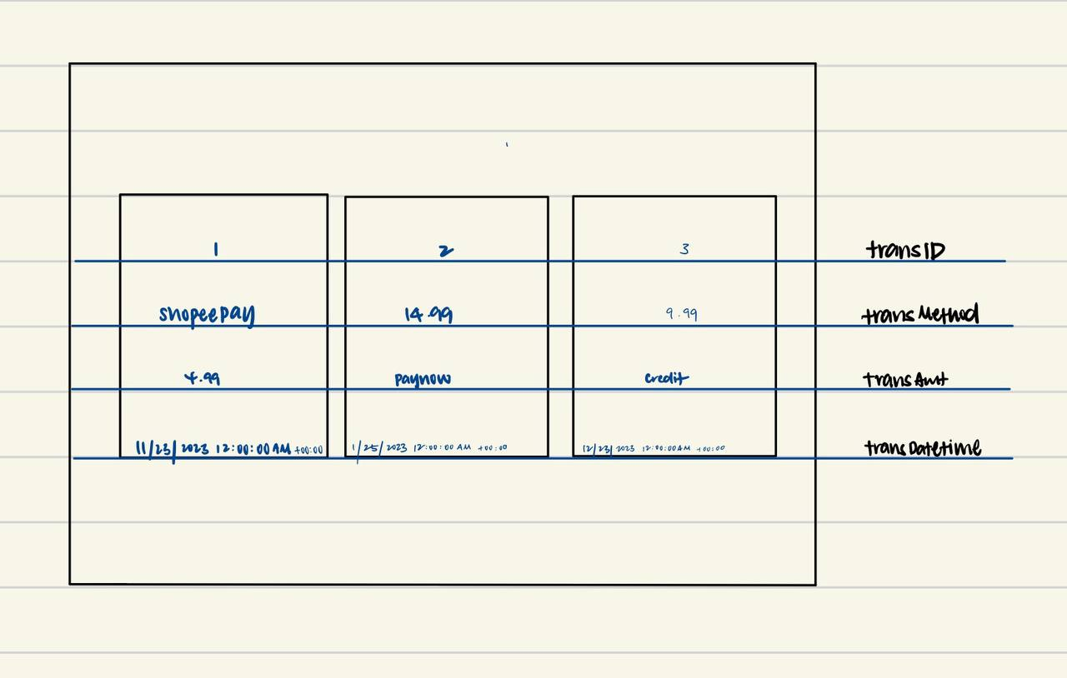

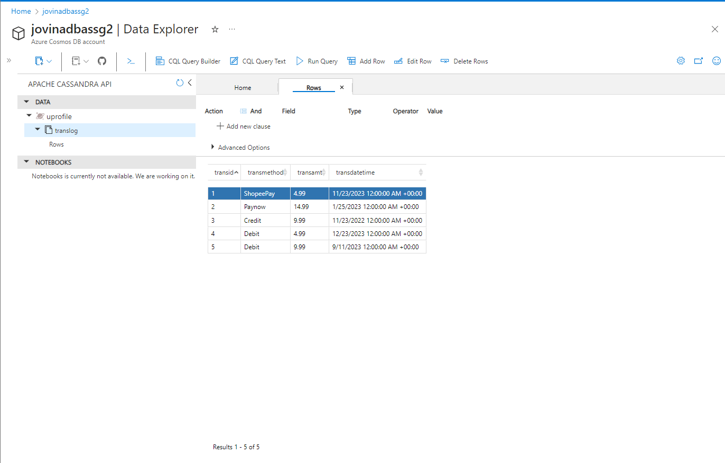

Figure 26 Azure Columnar Database attempt for TansLog table



### Business Queries (revised)

1. Who are the top 5 users who shared the highest number of playlists per country? (Jovin Wong See Xuan, S10243666)

SELECT userID, username, count(playlistID) as 'Number of playlists'

FROM UserCountry u

INNER JOIN Playlist p ON u.userID = p.userID

GROUP BY userID, countryCode

ORDER BY count(playlistID) DESC

LIMIT 5;

1. Shortest number of days needed for a user to subscribe for premium plans? (Jovin Wong See Xuan, S10243666)

SELECT userDateJoined, subDateJoined, DATEDIFF(DAY, subDateJoined, userDateJoined) as 'Days to become a subscriber'

FROM Users u

INNER JOIN Subscriber s ON u.userID = s.subID

GROUP BY userID

ORDER BY DATEDIFF(DAYS, subDateJoined, userDateJoined) ASC

LIMIT 1;

1. Which subscription plans have the highest number of subscribers? (Done by Jovin Wong See Xuan, S10243666)

SELECT subID, planType, SUM(subID) as 'Number of subscribers'

FROM SubscriptionNormalised

GROUP BY subID, subPlanType

ORDER BY count(subID) DESC

LIMIT 1;

## Ern Qi

### Followers Table

**1.Data Placement Strategy**

***Partition by Follower and Following***

As a database designer focused on optimizing the social network's performance, I've chosen to implement a data partitioning strategy that organizes the data based on user relationships. Specifically, I've divided the data into two distinct parts: one that keeps track of who each user follows, and another that tracks who is following each user. This structure is intended to streamline the retrieval of followers and followings for any given user.

Let's take a closer look at how I've split the original Followers table into two separate tables for a clearer and more efficient design:

* **UserFollowers** - This table records the followers for a given user. It uses the userID of the person being followed as the partition key, grouping all follower relationships for that user in the same partition, which simplifies the process of querying a user's followers.
* **UserFollowing** - This table keeps track of the users that a given user is following. It also uses the userID of the follower as the partition key, keeping all following relationships for that user in the same partition, which simplifies the process of querying who a user is following.

Pre-partitioned Table:

| **userID** | **dateFollowed** | **followerID** | **FollowedID** |
| --- | --- | --- | --- |
| 4965 | 2021-02-21 04:44:03 | 7597 | 8328 |
| 1113 | 2022-10-25 13:41:48 | 3016 | 9665 |
| 8644 | 2023-08-27 19:29:48 | 9998 | 8232 |
| 3469 | 2022-06-06 18:46:14 | 6871 | 7307 |
| 7677 | 2020-08-01 06:14:00 | 1770 | 2496 |

Here's an example of what these two tables might look like after this partitioning:\

UserFollowers Table:

| **userID** | **FollowerID** | **dateFollowed** |
| --- | --- | --- |
| 8328 | 7597 | 2021-02-21 04:44:03 |
| 9665 | 3016 | 2022-10-25 13:41:48 |
| 8232 | 9998 | 2023-08-27 19:29:48 |
| 7307 | 6871 | 2022-06-06 18:46:14 |
| 2496 | 1770 | 2020-08-01 06:14:00 |

**UserFollowing table:**

| **userID** | **FollowingID** | **dateFollowed** |
| --- | --- | --- |
| 7597 | 8328 | 2021-02-21 04:44:03 |
| 3016 | 9665 | 2022-10-25 13:41:48 |
| 9998 | 8232 | 2023-08-27 19:29:48 |
| 6871 | 7307 | 2022-06-06 18:46:14 |
| 1770 | 2496 | * + 1. 6:14:00 |

**2.Selection of Cloud Storage Strategies**

I would choose column storage for the followers entity because it offers several advantages for specific use cases typically associated with social networking platforms where the followers entity is used. Column storage databases store data tables by column rather than by row, making it more efficient for querying and aggregating data over fewer columns but many rows, which is common in such scenarios. Here are some reasons why I would use column storage:

1. **Improved Read Performance:** When retrieving the list of followers or followings for a user, the database only needs to read from the specific columns that contain user IDs. Column storage excels at such read-intensive operations, especially when the queries only involve a subset of columns.
2. **Analytical Queries:** Social networks often need to perform analytical queries, such as counting the number of followers, filtering by date ranges, or aggregating user activity. Column storage is well-suited for these operations because it can scan and perform calculations on the relevant columns rapidly without the overhead of processing the entire row.
3. **Scalability for Big Data:** Social networks can generate massive amounts of data. Column storage databases are designed to scale out and handle big data workloads more efficiently than traditional row-based databases, especially for read-heavy workloads like those involving the followers entity.
4. **Real-time Analysis** and Reporting: If the platform requires real-time analysis and reporting on user engagement and trends, column storage allows for faster aggregation and filtering, which is essential for generating real-time insights

**3.Design / Schema and Content of Cloud Storage**

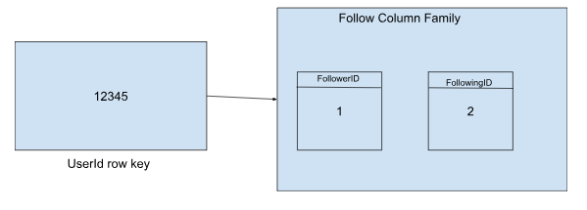

Table Name: UserFollowers

Partition Key: userFollowerID

* Description: Groups all follower relationships for a particular user into a single partition for efficient query performance on user-specific data.

Clustering Columns:

* dateFollowed

Description: Orders the followers within each user partition by the date and time they started following. Useful for chronological queries.

* followedUserID

Description: Serves to uniquely identify the user being followed within the same following date and allows sorting within the partition.

Schema Details:

* The userFollowerID is used as the partition key to ensure that all following relationships for a specific user are stored together, optimizing the retrieval of follower data for an individual user.
* The dateFollowed is a clustering column that orders the followers within each user partition chronologically, which is beneficial for queries that involve a time range or need to access the most recent followers.
* The followedUserID is also a clustering column and ensures that the followers are uniquely identified within each follow date, allowing for sorting and unique identification within the partition.

Table Name: UserFollowing

**Partition Key:** followedUserID

* **Description:** Groups all following relationships for a particular user who is being followed into a single partition for efficient query performance on user-specific data.

**Clustering Columns:**

1. dateFollowed
   * **Description:** Orders the following relationships within each followed user partition by the date and time they were followed.
2. userFollowerID
   * **Description:** Serves to uniquely identify the user following within the same follow date and allows sorting within the partition.

**Schema Details:**

* The **followedUserID** is used as the partition key to ensure that all users following a specific user are stored together, which optimizes the retrieval of following data for an individual user.
* The **dateFollowed** is a clustering column that orders the following relationships within each followed user partition chronologically, which is beneficial for time-based queries.
* The **userFollowerID** is also a clustering column and ensures that the following relationships are uniquely identified within each follow date.

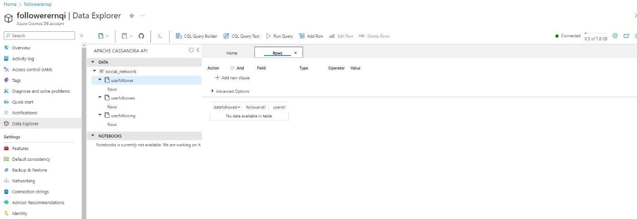

### Recommendations Table

**1.Denormalization**

**Denormalizing recommendations table to include artist name, album name and song name.**

Denormalization is the process of restructuring a relational database to reduce join complexity and improve read performance. By including descriptive fields directly in the Recommendations table, queries intended to retrieve recommendations with detailed information about the songs, artists, and albums can be executed more efficiently because the information is already present in one table, eliminating the need for multiple joins to related tables.

**Before Denormalization:**

Artist Table:

| **artistID** | **artistName** |
| --- | --- |
| 101 | Artist One |
| 102 | Artist Two |

Song Tale:

| **songID** | **songName** | **artistID** |
| --- | --- | --- |
| 201 | Song One | 101 |
| 202 | Song Two | 102 |

Album Table:

| **albumID** | **albumName** | **artistID** |
| --- | --- | --- |
| 301 | Album One | 101 |
| 302 | Album Two | 102 |

Recommendations Table:

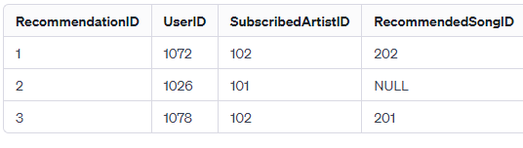

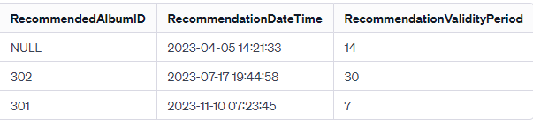

(this is one table, split for convenient viewing)

**After Denormalization:**

Recommendations Table:

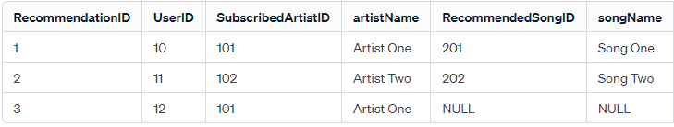

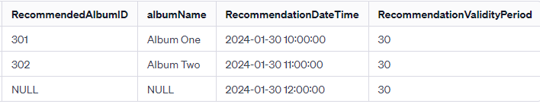

(this is one table, split for convenient viewing)

Selection of data before and after denormalization:

**Before denormalisation:**

*SELECT*

*r.RecommendationID,*

*u.username,*

*a.artistName,*

*s.songName,*

*al.albumName*

*FROM*

*Recommendations AS r*

*INNER JOIN Users AS u ON r.UserID = u.userID*

*INNER JOIN Artist AS a ON r.SubscribedArtistID = a.artistID*

*INNER JOIN Song AS s ON r.RecommendedSongID = s.songID*

*INNER JOIN Album AS al ON r.RecommendedAlbumID = al.albumID*

*WHERE*

*UserID=123;*

**After denormalisation:**

*SELECT*

*RecommendationID,*

*username,*

*ArtistName,*

*SongName,*

*AlbumName*

*FROM*

*Recommendations*

*WHERE*

*UserID = 123:*

**2.Data placement strategy**

* *Partition by artist*
* *Partition by User*

Before Partitioning:

Recommendations Table (Unpartitioned):

| **RecommendationID** | **UserID** | **ArtistName** | **SongName** | **AlbumName** |
| --- | --- | --- | --- | --- |
| 1 | 10 | The Fake Band | Imaginary Love | Greatest Hits |
| 2 | 20 | The Fake Band | Another Hit | Greatest Hits |
| 3 | 15 | Another Artist | New Beginnings | New Album |
| 4 | 25 | Another Artist | Song of Summer | New Album |
| 5 | 10 | Solo Singer | The Lonely Tune | Solo Album |
| 6 | 20 | Duo Band | Together Always | Duo Hits |

**Partition by Artist:**

Partitioning the Recommendations table by artist means that all recommendations related to a particular artist would be stored together in the same partition. This can be particularly efficient if there are operations or queries that frequently access recommendations by artist.

Partition 1: Recommendations for Artist 'The Fake Band'

| **RecommendationID** | **UserID** | **ArtistName** | **SongName** | **AlbumName** |
| --- | --- | --- | --- | --- |
| 1 | 10 | The Fake Band | Imaginary Love | Greatest Hits |
| 2 | 20 | The Fake Band | Another Hit | Greatest Hits |

Partition 2: Recommendations for Artist 'Another Artist'

| **RecommendationID** | **UserID** | **ArtistName** | **SongName** | **AlbumName** |
| --- | --- | --- | --- | --- |
| 3 | 15 | Another Artist | New Beginnings | New Album |
| 4 | 25 | Another Artist | Song of Summer | New Album |

**Partition by User:**

Partitioning by user means that all recommendations for a specific user would be stored together. This can significantly speed up queries that retrieve a user's recommendations since the data is localized to a specific partition.

Partition 1: Recommendations for UserID 10

| **RecommendationID** | **UserID** | **ArtistName** | **SongName** | **AlbumName** |
| --- | --- | --- | --- | --- |
| 1 | 10 | The Fake Band | Imaginary Love | Greatest Hits |
| 5 | 10 | Solo Singer | The Lonely Tune | Solo Album |

Partition 2: Recommendations for UserID 20

| **RecommendationID** | **UserID** | **ArtistName** | **SongName** | **AlbumName** |
| --- | --- | --- | --- | --- |
| 2 | 20 | Another Artist | New Beginnings | New Album |
| 6 | 20 | Duo Band | Together Always | Duo Hits |

**3.Selection of cloud storage strategies**

In my assessment of the appropriate cloud storage strategies for the Recommendations table within Musify's platform, I've determined that a document database is highly advantageous. The decision to favor a document store over a relational database stems from the specific needs of our application, particularly as they relate to scale and flexibility.Advantages of Using a Document Database for Musify's Recommendations Table:

* **Schema Flexibility:** I've found that the schema-less nature of document databases is particularly beneficial for Musify. It allows us to store diverse recommendation data, each potentially having different attributes, without conforming to a rigid table schema. This flexibility is invaluable as we continually evolve and expand our recommendation features, allowing us to seamlessly introduce new data fields or modify existing ones.
* **Scalability:** Another compelling reason for my choice is the scalability that document databases offer. They excel at horizontal scaling, distributing data across a cluster of machines, which is essential for accommodating the significant volume of recommendations generated and accessed by our growing user base.
* **Handling Complex Data Structures:** The structure of our recommendations is inherently complex, often involving nested information about songs, artists, and albums. Document databases allow us to embed this information within a single document. This capability eliminates the need for multiple joins that would be necessary in a relational database, thereby streamlining data retrieval.
* **Rich Querying Capabilities:** The querying capabilities offered by document databases are robust and well-suited to the complex queries required by our recommendation system. Whether we're generating personalized recommendations or analyzing user behavior, the document database provides the tools we need to perform these tasks efficiently.

**4.Design/schema and content cloud storage**

Queries and the Specific Data Application Requires:

Musify's application needs to access user recommendations efficiently, which includes details about the songs, artists, and albums recommended to a user. Our queries are tailored to fetch this information based on user preferences and listening history.

What Are the Relationships Between Data (Linked or Embedded):

* The Recommendations table has a one-to-many relationship with users—one user can have many recommendations. It also has a one-to-many relationship with artists—each artist can be associated with many recommendations.

Schema Design – Link or Embed?

* Given the nature of our data, we prefer to embed the relevant artist and song details directly within the Recommendations table. This is more efficient for our use case than linking to separate Artist or Song tables, which would require additional joins or lookups.
* **One to Many / One to Few:** A one-to-many relationship exists between users and recommendations, as well as between artists and recommendations. We don't have a 'one to few' scenario since the number of recommendations can vary widely and is not limited to a small number
* **One to Many:** This is the primary relationship type in our Recommendations table, where each user may have multiple recommendations, and each artist may be associated with multiple recommendations
* **Many to Many:** A many-to-many relationship could be considered between users and artists indirectly through recommendations. A user can subscribe to many artists, and an artist can be subscribed by many users.

***Example of recommendation document***

*{*

*"recommendationID": "rec123",*

*"user": {*

*"userID": "user456",*

*"username": "musiclover"*

*// Other embedded user details if necessary*

*},*

*"artist": {*

*"artistID": "artist789",*

*"artistName": "The Fake Band",*

*"songs": [*

*"Imaginary Love",*

*// ... other song names by "The Fake Band" ...*

*],*

*"albums": [*

*"Greatest Hits",*

*// ... other album names by "The Fake Band" ...*

*]*

*},*

*// Other embedded artists*

*"recommendationDateTime": "2024-01-01T12:00:00Z",*

*"recommendationValidityPeriod": 30*

*}*

**Partitioned by Artist:**

*{*

*"partitionKey": "The Fake Band",  // This is the artist name used for partitioning*

*"recommendations": [*

*{*

*"recommendationID": "rec123",*

*"user": {*

*"userID": "user456",*

*"username": "musiclover"*

*},*

*"songNames": ["Imaginary Love"],*

*"albumNames": ["Greatest Hits"],*

*"recommendationDateTime": "2024-01-01T12:00:00Z",*

*"recommendationValidityPeriod": 30*

*},*

*// ... other recommendations for "The Fake Band" ...*

*]*

*},*

*{*

*"partitionKey": "Another Artist",*

*"recommendations": [*

*// ... recommendations for "Another Artist" ...*

*]*

*// ... other artist partitions ...*

*}*

**Partition by User**

*{*

*"partitionKey": "user456",  // This is the user ID used for partitioning*

*"recommendations": [*

*{*

*"recommendationID": "rec123",*

*"artistName": "The Fake Band",*

*"songNames": ["Imaginary Love"],*

*"albumNames": ["Greatest Hits"],*

*"recommendationDateTime": "2024-01-01T12:00:00Z",*

*"recommendationValidityPeriod": 30*

*},*

*// ... other recommendations for user "user456" ...*

*]*

*},*

*{*

*"partitionKey": "user789",*

*"recommendations": [*

*// ... recommendations for user "user789" ...*

*]*

*// ... other user partitions ...*

*}*

### Advertising Table

**1.Data Placement strategy**

**Partitioning by Ad Advertiser:** Partitioning by ad advertiser is a strategy where advertisements are grouped based on the company or entity that is sponsoring the ads. This approach aligns with operations that are frequently executed in relation to advertisers

**Partitioning by Ad ID:** Partitioning by ad ID involves organizing our database such that each advertisement is stored in its own partition. This is particularly advantageous for operations that focus on individual advertisements, such as detailed analytics on ad performance.

Before Partitioning:

| **adID** | **adDescription** | | **adStartDate** | **adEndDate** | **adAdvertiser** |
| --- | --- | --- | --- | --- | --- |
| 101 | Summer Music Fest | | 2024-06-01 | 2024-06-15 | GrooveTunes |
| 102 | End of Year Album Sale | 2024-11-01 | | 2024-11-15 | Vinyl Classics |
| 103 | Spring Indie Spotlight | | 2024-03-15 | 2024-04-01 | GrooveTunes |
| 104 | Jazz Nights Series | | 2024-09-20 | 2024-10-05 | Jazzify Records |

**After Partitioning by Ad Advertiser:**

Partition for "GrooveTunes":

| **adID** | **adDescription** | **adStartDate** | **adEndDate** | **adAdvertiser** |
| --- | --- | --- | --- | --- |
| 101 | Summer Music Fest | 2024-06-01 | 2024-06-15 | GrooveTunes |
| 103 | Spring Indie Spotlight | 2024-03-15 | 2024-04-01 | GrooveTunes |

Partition for "Vinyl Classics":

| **adID** | **adDescription** | **adStartDate** | **adEndDate** | **adAdvertiser** |
| --- | --- | --- | --- | --- |
| 102 | End of Year Album Sale | 2024-11-01 | 2024-11-15 | Vinyl Classics |

**After Partitioning by Ad ID:**

Partition for adID 101:

| **adID** | **adDescription** | **adStartDate** | **adEndDate** | **adAdvertiser** |
| --- | --- | --- | --- | --- |
| 101 | Summer Music Fest | 2024-06-01 | 2024-06-15 | GrooveTunes |

Partition for adID 102:

| **adID** | **adDescription** | **adStartDate** | **adEndDate** | **adAdvertiser** |
| --- | --- | --- | --- | --- |
| 102 | End of Year Album Sale | 2024-11-01 | 2024-11-15 | Vinyl Classics |

**2.Cloud storage strategy**

In developing Musify's cloud storage strategy, particularly for the advertising logic, I have decided to explore the utilisation of a graph database. This decision is driven by the intricate and interconnected nature of the relationships that exist between various data points in our advertising domain, such as ads, users, and targeting criteria.

Graph databases excel in scenarios where relationships are not just important but are central to the data model and the business logic. In Musify's context, we need to understand and leverage the relationships between ads and the users they target, as well as the various criteria that define these relationships.

For instance, a graph database would enable us to:

* Efficiently traverse the network of users and their attributes to identify those who meet the criteria for targeting specific advertisements.
* Analyse the connections between different ads and user engagement to optimise ad performance and user experience.
* Understand the relationships between advertisers and the various ad campaigns they run on Musify, making it easier to manage these campaigns and provide insights back to the advertisers.

**3.Design/schema and content of each cloud storage used**

**Nodes:**

* Advertisement Node: Represents an individual advertisement. Properties might include adID, adDescription, adStartDate, adEndDate, and adAdvertiser.
* User Node: Represents an individual user who might see the advertisement. Properties might include userID and any other demographic or user profile information.
* Criteria Node: Represents a targeting criterion for the advertisement. Properties might include criteriaID, key (e.g., "AgeGroup", "Genre"), and value (e.g., "18-24", "Pop").

**Relationships:**

* TARGETS: A directed relationship from an Advertisement Node to a User Node, indicating that the advertisement is targeted at this user.
* HAS_CRITERIA: A directed relationship from an Advertisement Node to a Criteria Node, indicating that the advertisement has specific targeting criteria
* MEETS_CRITERIA: A directed relationship from a User Node to a Criteria Node, indicating that the user meets the specified criteria (this relationship is optional and can be inferred through queries if the user properties align with criteria values).

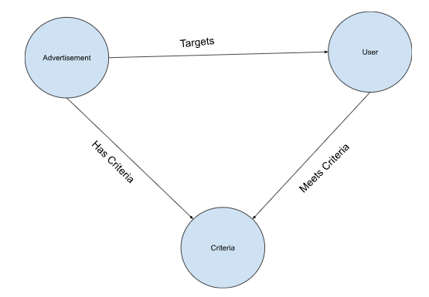

### Artist/Band Table

** Band is a subtype of artist

1**.Denormalization**

**Rationale for Denormalization:**

By embedding the band information within the artist's document, we are able to streamline the data retrieval process. When an application requests information about an artist who is also a band member, it can now access all necessary data—such as band membership, role, join and leave dates—directly from the artist's document, without the need for additional queries or processing to assemble this information from separate tables or collections.

**Normalised Structure:**

Artist Table:

| **artistID** | **artistName** | **artistDateOfBirth** | **artistAbout** |
| --- | --- | --- | --- |
| 1 | Solo Artist | 1975-05-22 | A solo artist with a unique sound. |
| 2 | The Rock Band | 1980-07-01 | A band known for its rock hits. |
| 3 | Jazz Ensemble | 1975-05-22 | A group that plays smooth jazz tunes. |

Band Table:

| **BandID** | **MemberID** | **JoinDate** | **LeaveDate** |
| --- | --- | --- | --- |
| 2 | 4 | 2001-01-01 | NULL |
| 2 | 5 | 2001-01-01 | 2005-12-31 |
| 3 | 6 | 2002-06-01 | NULL |

In the normalised structure, we have a clear separation of entities: individual artists and bands are in the Artist table, while the Band table records the membership details of artists in bands.

Artist Table (Denormalized):

| **artistID** | **artistName** | **artistDateOfBirth** | **artistAbout** | **BandID** | **MemberID** | **JoinDate** | **LeaveDate** |
| --- | --- | --- | --- | --- | --- | --- | --- |
| 1 | Solo Artist | 1975-05-22 | A solo artist with a unique sound. | NULL | NULL | NULL | NULL |
| 2 | The Rock Band | 1980-07-01 | A band known for its rock hits. | 2 | 4 | 2001-01-01 | NULL |
| 2 | The Rock Band | 1980-07-01 | A band known for its rock hits. | 2 | 5 | 2001-01-01 | 2005-12-31 |
| 3 | Jazz Ensemble | 1975-05-22 | A group that plays smooth jazz tunes. | NULL | 3 | 6 | 2002-06-01 |

**Normalised data retrieval:**

*SELECT a.artistID, a.artistName, b.JoinDate, b.LeaveDate*

*FROM Artist a*

*JOIN Band b ON a.artistID = b.MemberID*

*WHERE b.BandID = (*

*SELECT artistID*

*FROM Artist*

*WHERE artistName = 'The Rock Band'*

*);*

**Denormalized data retrieval:**

*SELECT artistID, artistName, artistDateOfBirth, artistAbout, BandID, MemberID, JoinDate, LeaveDate*

*FROM Artist*

*WHERE artistName = 'The Rock Band';*

**2.Data Placement Strategy**

*Partition by Artist ID (artistID)*

Partitioning by artistID would involve organising the data so that all information related to a single artist is stored together. In a denormalized Artist table, each row represents an artist, and if the artist is a band member, their band information is embedded within the same row.

Partition for artistID 1: Solo Artist

| **artistID** | **artistName** | **artistDateOfBirth** | **artistAbout** | **BandID** | **MemberID** | **JoinDate** | **LeaveDate** |
| --- | --- | --- | --- | --- | --- | --- | --- |
| 1 | Solo Artist | 1975-05-22 | A solo artist with a unique sound. | NULL | NULL | NULL | NULL |

Partition for artistID 2: The Rock Band

| **artistID** | **artistName** | **artistDateOfBirth** | **artistAbout** | **BandID** | **MemberID** | **JoinDate** | **LeaveDate** |
| --- | --- | --- | --- | --- | --- | --- | --- |
| 2 | The Rock Band | 1980-07-01 | A band known for its rock hits. | 2 | 4 | 2001-01-01 | NULL |
| 2 | The Rock Band | 1980-07-01 | A band known for its rock hits. | 2 | 5 | 2001-01-01 | 2005-12-31 |

**3.Selection of cloud storage strategies**

I have opted for a document-based database for Musify's denormalized Artist table for several compelling reasons. Document databases, such as MongoDB, are adept at managing denormalized data, making them an ideal choice for our requirements.

Here's why I've chosen to use a document database:

* **Handling of Nested Data:** Document databases are inherently designed to store and manage nested data structures. This capability is a perfect fit for our denormalized Artist table, where each artist or band's information, including details about band memberships, can be contained within a single, nested document
* **Schema Flexibility:** Document databases offer flexible schema design. This flexibility allows us to easily incorporate band membership information directly within the artist's document without the constraints of a fixed table schema. We can also adjust the structure as new requirements emerge, such as adding new attributes or changing the format of existing ones, all without the need for data migrations that would be necessary in a relational database.
* **Scalability:** Document databases are built with horizontal scalability in mind. They can be scaled out across multiple servers or clusters to handle large volumes of data and high throughput, which is essential for Musify as our user base and dataset grow.

**4. Design/Schema of cloud storage used**

**Queries and Data Requirements:**

Musify's application requires comprehensive artist profiles that may include details about solo artists and bands, along with the bands' member information. Our queries are designed to fetch complete artist data, often in a single operation, which is facilitated by the denormalized document structure.

**Schema Design – Link or Embed?:**

Based on our read and write patterns, embedding is the chosen approach. This eliminates the need for joins or cross-document references and aligns with the capabilities of document databases.

* **One to Many / One to Few:** This relationship applies to our Artist collection, where one band (a single artistID) has many members. However, the term 'few' can also be relevant if a band only has a small number of members, which still justifies the embedding approach.
* **Many to Many:** The many-to-many relationship is applicable when considering individual musicians who may play in multiple bands over their careers. However, within the scope of a single band's document, we treat the relationship as one-to-many, focusing on the band and its members.
* Document Schema for Solo Artists:
  + These documents will be straightforward, containing fields like artistName, artistDateOfBirth, and artistAbout.
  + Since these artists are not affiliated with any bands, the band membership-related fields will be absent or null.
* Document Schema for Bands:
  + The documents for bands will be more complex, including not only the band's information but also an embedded array named BandMemberships.
  + Each entry in the BandMemberships array will be a sub-document containing the MemberID, JoinDate, and LeaveDate, detailing each member's tenure within the band.

**Example Document for a Solo Artist:**

*{*

*"artistID": 1,*

*"artistName": "Solo Artist",*

*"artistDateOfBirth": "1975-05-22",*

*"artistAbout": "A solo artist with a unique sound."*

*}*

**Example Document for a Band:**

*{*

*"artistID": 2,*

*"artistName": "The Rock Band",*

*"artistDateOfBirth": "1980-07-01",*

*"artistAbout": "A band known for its rock hits.",*

*"BandMemberships": [*

*{*

*"MemberID": 4,*

*"JoinDate": "2001-01-01",*

*"LeaveDate": null*

*},*

*{*

*"MemberID": 5,*

*"JoinDate": "2001-01-01",*

*"LeaveDate": "2005-12-31"*

*}*

*]*

*}*

### Song Log Table

**1.Data Placement Strategy**

Partition by ArtistID:

If queries are often made to fetch data for a specific artist, partitioning by artistID can significantly improve query performance because the data for each artist is stored together, reducing the time to search through the entire table.

Unpartitioned:

| **sLogID** | **artistID** | **songID** | **sLogDateTime** |
| --- | --- | --- | --- |
| 1004 | 1 | 5359 | 2022-01-03 19:39:59 |
| 1002 | 1 | 2326 | 2022-08-13 00:35:59 |
| 1003 | 1 | 3523 | 2022-08-19 16:03:18 |
| 1000 | 1 | 6026 | 2023-03-17 12:18:58 |
| 1009 | 2 | 3311 | 2022-06-26 19:29:10 |
| 1008 | 2 | 9679 | 2023-01-18 00:55:15 |
| 1006 | 2 | 6617 | 2023-04-20 10:58:29 |
| 1007 | 2 | 9321 | 2023-08-02 09:18:43 |

**Partition for artistID 1:**

| **sLogID** | **artistID** | **songID** | **sLogDateTime** |
| --- | --- | --- | --- |
| 1004 | 1 | 5359 | 2022-01-03 19:39:59 |
| 1002 | 1 | 2326 | 2022-08-13 00:35:59 |
| 1003 | 1 | 3523 | 2022-08-19 16:03:18 |
| 1000 | 1 | 6026 | 2023-03-17 12:18:58 |

**Partition for artistID 2:**

| **sLogID** | **artistID** | **songID** | **sLogDateTime** |
| --- | --- | --- | --- |
| 1009 | 2 | 3311 | 2022-06-26 19:29:10 |
| 1008 | 2 | 9679 | 2023-01-18 00:55:15 |
| 1006 | 2 | 6617 | 2023-04-20 10:58:29 |
| 1007 | 2 | 9321 | 2023-08-02 09:18:43 |

**2.Cloud Storage Strategy**

I have evaluated the suitability of columnar storage for managing our song log data. Based on my analysis, I believe columnar storage offers several advantages for our specific needs, which I will outline below:

Analytical Queries: Columnar storage is optimized for read-heavy analytical queries that typically access only a subset of columns. For example, if you frequently need to analyze the most played songs across all artists, a query will access only the songID column, which is more efficient in columnar storage.

Aggregation Performance: Columnar databases are well-suited for aggregate functions (such as COUNT, SUM, AVG) since they can quickly scan and calculate results over one column without the need to process the entire row's data. This is beneficial for song log data when performing operations like counting the number of plays per song or artist.

Updates and Write Patterns: Although columnar storage is often associated with fewer write operations, when song log data is appended in a write-once-read-many (WORM) pattern, columnar databases can handle this efficiently. The new data can be added in large batches, which aligns well with columnar storage's bulk load operations.

**3.Design/Schema of Cloud Storage Used**

**Partition Key:** **artistID**

**Clustering Columns:** **sLogDateTime**, **sLogID**

**Data Columns:**

* **sLogID**: Integer/UUID (Unique song log entry identifier)
* **ongID**: Integer/UUID (References the unique ID of the song associated with the log)
* **sLogDateTime**: DateTime/Timestamp (The date and time when the log entry was created)

**Schema Details:**

* **artistID** serves as the partition key, which means that all song logs for a particular artist will be stored together. This is beneficial for queries targeting a single artist, as it will reduce the amount of data scanned.
* The **sLogDateTime** and **sLogID** serve as clustering columns within each partition. This ensures that the data within each artist partition is ordered first by the log's timestamp, allowing for efficient time range scans, and second by the unique log ID for uniqueness and additional sorting.

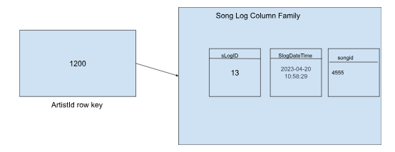

### Business Queries (revised)

Top 10 Artists with the most number of songs (Oh Ern Qi, S10243067)

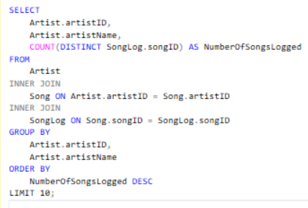;

Top Songs by number of listens for each Artists  (Oh Ern Qi, S10243067)

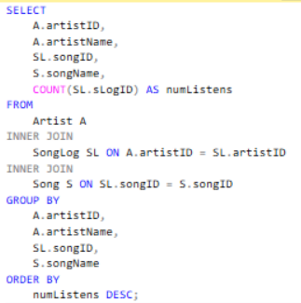

List Top 10 Countries with the Highest Number of Users (Oh Ern Qi, S10243067)

